# Executive Summary

The public transportation industry faces many different problems such as old equipment, deficits, low-profit models, and unsatisfied customers. In order to understand the situation, the team conducted primary research through surveys in the Boston public transportation areas.

The main problems travelers experience in Massachusetts are the inaccurate travel schedules, inefficient payment systems, different systems of business models, crowded transportation modes, and no good customer services.

The current trend is to solve discrepancies with new technologies such as Internet of Things (IoT) and artificial intelligence, which allows for automatization and the exchange of data. Keeping these shortcomings in mind, the team investigated in the integration of 5G and IoT. The main stakeholder in providing modernized technological solutions would be one of the major telecommunication players – Verizon.

The public transportation industry can widely benefit from the next-gen wireless network. It can ease the usage of public transport by giving real-time traffic updates, suggested routing/schedules, and break the hassle of payment by incorporating mobile wallets along with a curated mobile application.

In order to formulate a solution, secondary research, benchmarking techniques, associating, the 10 types of innovation, and the brand identify communication matrix are applied. Our solution to the problem centered on the experiences of travelers involves the investment in net 5G enabled IoT equipment with the integration of a mobile application.

The new equipment allows the data to be more accurate while 5G enables high speed transfer of data. This solves the problem of inaccurate scheduling and allows real-time demand planning. The mobile application enables the function of getting a unified unique ticket through a digital wallet without going to locations of different providers. Furthermore, it also enables a unified customer service and a reward loyalty program that stimulates the public to take transportation more often while getting discounts for convenience products during their traveling journey. The business model includes gathering money as a commission fee on top of prices, in-app advertisements, and selling the data ethically to third parties.

The prototype of the model application was first drawn-out on paper sketches and then further developed in a digital version. Benchmarking UX designs were used in order to create a seamless flow within the app which allows to establish trust. The design was based on famous applications such as Google Maps, Uber, and Lyft.

In order to confirm whether the solution created works, the team conducted multiple focus group discussions showing a video of the prototype. It can be concluded that the problems identified were the ones that travelers were facing. In addition, many respondents would solve the problems by introducing a new app or modifications to the current infrastructure. Some suggestions were made to look deeper in the intellectual property rights to protect our idea and look into measurements in order to prevent fraud.

Taking all the findings into account, it can be said that the solution created is a suitable option to solve the problem. The project should be implemented starting with the Boston area, and later expending to the rest of the state. After the first implementation, the concept can be stretched to other areas within the United States such as New York City, NY and Chicago, IL.

# Table of Content

Executive Summary 2

Table of Content 3

1. Understand 4

1.1 Profit Models 4

1.2 Collaborations 4

1.3 Technological Issues 4

1.4 Different Operational Processes 4

1.5 Public Transportation Performance 5

1.6 Separate Systems 6

1.7 Customer Service 6

1.8 Ticketing Process 6

2. Problem 6

2.1 Observations Results 6

2.2 Survey Results 6

2.3 Problem Focus Areas 7

3. Solution 7

3.1 Problem Solution 7

3.2 U-go Business Model 9

3.3 Strategy 15

3 Prototype 18

4 Testing 18

5 Conclusion 20

Appendix 21

Appendix 1: Assumption list 27

Appendix 2: Stakeholder list 28

Appendix 3: Concepts/Models 31

Appendix 4: Idea Parking lot 32

Appendix 5: Team Description 33

Appendix 6 Sketches 36

Appendix 7 Digital Prototype 40

Appendix 8: Dataset_Understanding _Problem 44

Appendix 9 Observations / Experiences 47

Appendix 10 The Business Model Canvas. 49

Appendix 11 Personas 50

Appendix 12 Customer Journey 52

Appendix 13 Estimated Return on Investment 53

Appendix 14 Prototype Benchmarking 54

Appendix 15 Transcripts Focus Group Testing Prototype 55

# Understand

Our interest towards the technological modernization of the public transportation system in Massachusetts was driven by our everyday hassles of using the public transport. Our hassles included delays in the train, infrequency of the buses, prolong waiting time, just to name a few. There are 16 different public transportation providers in Massachusetts and a few private operators. For each different provider in Massachusetts, different apps, tickets, waiting times, and systems are utilized, which makes the customer journey inefficient ( Commonwealth of Massachusetts., n.d.; MassDOT Planning , 2015). According to our research and observations, we have identified the main problems of the Public Transportation in Massachusetts.

## 1.1 Profit Models

Each provider in Massachusetts have their own profit model for the various types of products and services. Majority of them have models where the customer pays for the trip from and to a specific location. Other business models include a fee regardless of the destination. The transition between the different profit models does not create a smooth experience for the traveler.

Furthermore, on the provider’s end, there are several problems as well. Customers express that the public transportation model is expensive in regards to the service that is being received. The lack of funding and the low revenue has generated crisis of having a large amount of debt. The inefficiency in the design and product performance of the transportation systems has paved path for the commuters to avoid the payment system, that is crucial for revenue generation as more than 50% of public transportation providers are non-profit organizations. (Massachusetts Bay Transportation Authority, n.d.; Peter Pan Bus Lines, n.d.; Cape Ann Transportation Authority, n.d.; Cape Cod Regional Transit Authority, n.d.; Nantucket Regional Transit Authority, n.d.; Worcester Regional Transit Authority, n.d.; Franklin Regional Transit Authority (FRTA), n.d.; Acitelli, 2019; u/eatingandinternet, 2015).

## 1.2 Collaborations

The lack of collaboration within the various network partners/stakeholders is because they predominately rely on the various sources of government funding (American Public Transportation, 2019). Although, there are a network of companies that are willing to provide a better, reliable, safe, affordable, and sustainable transportation system (Transportation for Massachusetts , n.d.).

## 1.3 Technological Issues

With the prevailing deficit of the current structural budget, utilization of the scarce R&D funds for irrelevant purposes, reduces the probabilities of new and emergent technologies to be brought in action (United States Congress House Commitee on Appropriations, 2016). As of the current Massachusetts Public Transportation system lacks an integrated digitized platform, we assume that they do not collect commuter’s data which prevents them from delivering an accurate and seamless travel experience (see Appendix A).

## 1.4 Different Operational Processes

The Massachusetts Bay Transportation Authority (MBTA) which is the governing service body of Greater Boston public transportation and 15 other regional transit areas is bureaucratic in administration which furthermore leads to discrepancy in the functioning and process of streamlining the different layers of people and systems (Massachusetts Government, 2020).

## 1.5 Public Transportation Performance

The problem pertaining to the investment of hardware equipment for modification and upgrade of the systems along with the development of the application of MBTA. Due to the underlying reason of insufficient funds ($480 Million in the Fiscal year 2019) of the state is linked to the fluctuation of revenue of the sales tax (Acitelli, 2019). The various problems related to transportation performance are (Moovit Insights, 2019):

Bostonian who regularly travel with public transportation spend an average of 50 minutes to commute, which is more than expected. Moreover, when the commuters have transfers, they are required to wait a minimal of 11.45 minutes, which is presumed to be a long time. People who live here need to take an average of more than three commutes per trip, which is inconvenient, especially during winter (Moovit Insights, 2019).

During rush hours the transportation modes are crowded due to unforeseen demand, which results in a longer wait-time. Commuters also expressed their concerns about the unhygienic environment within the public transportation system. Lastly, disabled people have a hard time assessing the transportation mode that can be used by them. (Moovit Insights, 2019).

Due to the performance of the transportation system, there are concerns for the effect on the environment. Boston emitted 6.1 million metric tons of greenhouse gases (GHGs) of which 29 was caused by transportation. Currently, the reason why people avoid public transportation results in an increase in the usage of other transportation methods, which in turn contributes to a higher emission (City of Boston, 2019; Cleveland, et al., 2019).

Figure 1: Average Commute Time (Moovit Insights, 2019)

Figure 2: Average Wait Time) (Moovit Insights, 2019)

Figure 3: Number of transfers per trip (Moovit Insights, 2019)

## 1.6 Separate Systems

The current Boston public transportation system has five transit applications for helping to navigate the T system, namely: Trip Planner, Track the T, Transit App, ProximiT as well as Aira - the pilot test app (Acitelli, Curbed Boston, 2019). However, there are many more such as Google, Ride Match, and Transit. The accuracy of the arrival times is unreliable, tracking applications such as Google or Transit often reflect inaccurate information. The General Transit Feed Specification (GTFS), which is used to share data with these apps are not tracked in real-time, which makes it an unreliable source. There is currently no alternative available (Google Developers, n.d.; Moovit Insights, 2019). Moreover, the pricing scale in these applications are not easily understandable in comparison to the benchmark of other mobile platforms.

## 1.7 Customer Service

Based on our personal observation and researches, we have identified the inefficiency and lack of support staff during weather crisis of the cold Boston winters with the passengers made to wait for prolonged hours as the trains and bus services are lessened (Cross, 2018). The customers service is not available anytime and anywhere in Boston. The customer service opens from Monday to Friday: 6:30am-8:00pm; Saturday & Sunday: 8:00am-4:00pm. Most trains run between about 5:00am and 1:00am, and some lines have service as late at 1:50 AM. The commuters who take the late train cannot find any assistance if need. The customer service does not pertain to every station. Customer service booths only operate in some major stations. The customers services numbers are dispersive. The passengers need to check the providers and its number before they ask for help (Massachusetts Bay Transportation Authority,, n.d.)

## 1.8 Ticketing Process

The channel of delivery for the ticketing services (Charlie-card) to the commuters has been done in a very traditionalistic approach (vending kiosk) which, at times, has led to the inefficiency of quick recharging. Herewith, that causes friction with the seamless digitized delivery of ticketing processes (Runge, 2020).

# Problem

In order to narrow down the number of problems, observations and interviews have been conducted in Boston at Park Street, Logan International Airport, Boston University, Malden, Community College, Downtown crossing, Lechmere, Science Park, and South Station. The providers that are observed are Amtrak, Peter Pan Bus line, and MBTA. As the focus of this project are millennials (age 23-35), a sample size of 41 people has been selected. This is based on the millennial population of 172.000 within Massachusetts, a confidence level of 80%, and an error margin of 10% (Ryan, 2019; SurveyMonkey, n.d.). The team was able to conduct 54 surveys of which is dataset is presented in appendix 8.

## Observations Results

As there are many transportation providers, the following insights of the observed; MBTA, Amtrak, and Peter Pan Bus Lines. Appendix 9 presents the different observations and experiences over a longer period. These providers were choses due to its accessibility.

## Survey Results

The team interviewed and observed commuters and collected several results about the traveler’s satisfaction. This helped to identify in which areas they believe Massachusetts public transportation could improve. The result showed that only 19% of the people are satisfied about the ticket prices, and 83% of the respondants consider that the long waiting time is a key issue. In addition, 78% people think their customer service has to improve. There are 83% travellers who are not satisfied about the frequency of transportation, also 78% of the people do not like the Number of transfers. Furthermore, 63% of respondants are dissatified with the Ticket purchase process (Team 10 (MIM3), 2020).

*Figure 4: Percentage of people that are not satisfied Figure 5: Frequency of Travelling (Team 10 (MIM3), 2020) (Team 10 (MIM3), 2020) (Team 10 (MIM3), 2020)*



## 2.3 Problem Focus Areas

Based on the survey results, observations, and secondary research conducted it would be realistic to focus on the elements in which providers and customers have pain points. Furthermore, the solution cannot touch upon all different problem areas of the current transportation industry as this is not realistic due to high investments. These are the categories of the Ten Types of Innovation Model that U-Go is focusing on;

* Network (improving collaboration)
* Process / Product system (layers of different features, models, quality)

Product performance (reliability, transfer options, crowdedness, frequency of options, wait times, Co2 Emissions, availability & efficiency of ticketing process)

* Service (Customer service)
* Customer engagement (lack of digitalization)

# Solution

## 3.1 Problem Solution

In order to solve the identified product performance problems, the team has looked into 5G-Enabled Internet of Things (IoT) equipment. This equipment involves sensors, wired/wireless connectivity, devices, a mobile application, and a database to store the data collected (Ranger, 2020).

The technology could be used in many different ways. For supply chain networks, it can enable more accurate planning and inventory, on the customer side it can create an enhanced customer experience, new product extension can be developed, and it can act as the basis for infrastructure monitoring (Daecher & Schmid, n.d.). This technology facilitates the creation of the concept of SMART public transportation. There are some case examples analyzed in to determine whether this concept can be applied within the state of Massachusetts;

1. The Netherlands uses IoT sensors within the ProRail to understand the conditions of the current transportation system. The independent transportation companies had the problem of accurately tracking their systems, which at some point could not be done anymore by a human. It optimized the scheduling, improved track monitoring, and prevent a train from not driving (Horwitz, 2020).
2. The capital of Austria operates 154 different routes, which are navigable through the app “Qaundo” which is permitted with multiple sensors guidance systems, information updates at stations, and personalized routing applications. This improved the customers' satisfaction with the public transportation system (Pod Group, 2019).

As these countries are considered to have “Smart” public transportation systems, it can be assumed that, these cases are viable to be used as successful benchmarking examples by placing sensors in the different transportation modes, such as buses, trains, metros, and bikes. The 5G-enabled-sensors send real-time geographic information about the public transportation units to a mobile application and boarding locations information-displays. This will improve the issue with inaccurate presentations of the current mobile application that works with delayed API (application program interface) information transfers.

Benchmarking current navigations applications gives insights on how some of their features are already enabled. Google uses algorithms in order to determine the best routes to travel within the given timeframe. Uber includes this algorithm while also taking in factors such as demand and supply of riders, which determine the price (Wirth, 2018; Uber B.V., n.d.).

Furthermore, to collect data and money in real-time, QR code scanners should be integrated within the public transportation units that allow connectivity with the mobile application. This conclusion is based on the transportation system in China. The company Tencent Holdings Ltd introduced a digital card/wallet system within the Shenzhen and many more areas within China. The digital wallet is incorporated into the app, which makes the traditional paper tickets irrelevant. Digital bank accounts are connected to this wallet (Feifei, 2018). This concept will be incorporated within U-go’s channel innovation as it reduces the problem of access to ticket services.

The number of transfers, the best route, and the pricing should be recommended based on personalization of real-time algorithms. Personalized algorithms include the option of having chosen variables in order to determine the best route while meeting the requirements of the traveler. Uber has the option to select the number of riders while Google enables the option of choosing a preferred type of transportation mode or adding stops (Wirth, 2018; Uber B.V., n.d.; Koponen, 2015). U-Go should incorporate these options but make it more specific.

The cumulative price (including the fee) will be calculated, focusing primarily on the distance and the number of transfers, and the various providers. This pricing will be offered per trip and other extensions; such as monthly, quarterly, and annual subscriptions. The Netherlands applied this method to its current transportation system (ov-chipkaart.nl, n.d.). Based on the chosen payment offer, the charging process will be different. Vending tickets will simultaneously exist with tickets in the first period of implementation for a better transmission. This ticket system might be more convenient for an older target market.

The concept of demand planning, which is actively used in supply chain management, is utilzed to detect customer purchasing patterns. Weather conditions often can affect demand forecasting. With real-time digitalization, supply chain managers can find solutions for disruptions. Data is shared within the industry between manufacturing and retail organization to create planning. Uber is using machine learning to track behaviors within the application (JUNGHANNS, 2019; Smyl & Bell, 2018). The association of this concept could be applied within the application to get data on the consumer side to predict demand for scheduling. Customers can schedule their ride in advance and check in on the boarding platform to establish a system of real-time scheduling through prediction algorithms. This feature will resolve the wait times, the crowdedness, and the frequency of transportation.

Geo-fencing is a method that has been used in many different applications. Apple uses it to send reminders to pick-up order, Sephora sends push notifications to notify the customer about promotions, ProximiT, one of the current applications in the public transportation system in Boston, sends notifications. This all happens whenever the customer is located near the desired location (Perro, 2016). This technology applies to the U-go application. Whenever the customer is nearby a stop or location related to the advertisement, push notifications will pop-up if this fits within their travel journey.

In order to create seamless experience, information points on the boarding platforms will be accessible via image artificial intelligence recognition feature enabled within a camera that will provide real-time information. This feature has been implemented by Google and also tested by Perficient Digital Labs to enhance the experience in public transportation (Fedewa, 2020).

## 3.2 U-go Business Model

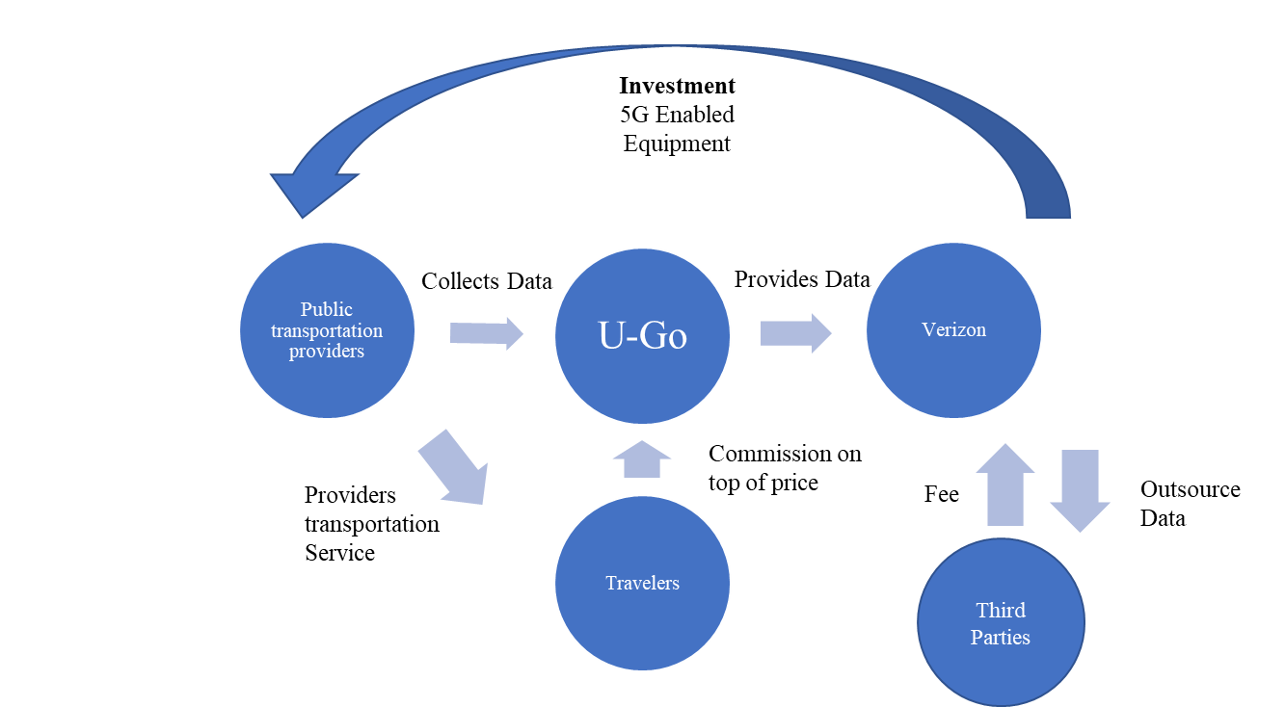

Figure 6: Business Model

In order to operate, Verizon should invest in the service loop for optimizing the public transportation system. Verizon launches the new technological service equipment to support providers to solve the problems and attributes by enhanced data collection through 5G (Bischoff, 2014; mobileworldcapital, 2013) U-go’s App is powered by Verizon, the app will collect the data and generate revenue for the business model. The data generated from different travelers will be collected and analyzed by Verizon’s partner to be used as the open source to third parties. Verizon can use the analysis of data to optimize the varying providers services and operation to help them decrease the cost and achieve more satisfaction from end-users (Helling, 2020). The Business Model Canvas is presented in Appendix 10.

### 3.2.1 Profit Model

#### Commission Fee

U-go charges 5%-8% commission fee for each ride with different loyalty using of the application as U-go provides premier riding experience to passengers as to optimize their customer journey. For instance, Uber and other food delivery platform charge commission fee to customers so to provide high-grade service .

#### In-App Advertisements

U-GO app generates revenue with digital advertising- display banner ads. Therefore, making alliances with companies that want to have exposure with a wide range of users that is essential to our business. As an average person looks at their phone over 150 times per day, we believe partnering with companies nearby the user’s destinations to showcase ads that give them special promotions or other incentives, enhancing the likelihood of visits and sales to their business. U-Go will harness the power of location-data as well as proximity targeting to reach the right people and encourage them to visits their stores (GroundTrouth, n.d.).

#### Selling Data

Several private firms and governmental organizations are potentially waiting to gain the customer data with the help of CSP (Customer Service Provider) networks. The data types are categorized into 4; each having a different purpose and usage of the information collected

* IoT data – Several CSP’s are devising IoT by integrating millions of sensors and smart devices. Although the customer data acquisition is an added profit center of connectivity.
* Location data – Mobile carriers have unmatched access to the physical locations of their users. Third parties that benefit from this data / information include retailers, restaurants, public transportation industry, etc. This collected data is primarily utilized to understand and analyze the traffic and to send personalized information that is of necessity to the users.
* Transportation data – State and local governments are the primary customers for the data that is mined by the CSPs and their partnering networks. The information collected can help manage traffic flows, emergency services and even provide the customers with accurate details of transportation as per their needs and usage habits.
* Mobile device data – Advertisers are willing to pay a high price for the collected data from CSPs. This collected data helps them to channelize and target better to their customers.

The various types of data collected can be optimized/utilized for 3 main purposes such as;

* Enhanced customer service – This helps in understanding the needs of the customer and enhancing their services to retain customer loyalty.
* Forecast network capacity and create value-based network – This helps in maintain their infrastructure. Along with continuous monitoring of network parameters which in turn proliferates the operational efficiency.
* Demand secure connectivity – Retaining the network security is of significance for operators to sustain the trust of the users in their network and services.

Every essential industry has acquainted with the drastic changes brought about by big data, and the telecom industry is no different. The usage of big data in the telecom industry can have wide array of benefits that indirectly impact other industrial sectors as well. It can enhance the infrastructure, customer service and even improve revenue. The telecommunication industry is alternatively known as “The Next Big Data” industry. As they invasively capture, process and integrate the data of the customer with the help of their partnered big data company as an outsourcing act of data collection and integration. The purpose of tracking and integrating data is directed at increasing revenue by focusing on two factors namely:

* Generating a 360-degree view of the customer to extend efficient customer service
* Acquiring near real-time/real time analytics integrated with current data for improved understanding of customer centric objectives.

The tele giants bundle and sell their own customer data to various firms to generate revenue. Therefore, it is recommended that Verizon sells the data gathered through the U-Go application.

#### Expected Costs

It a complex app with Development, UI/UX design, Quality Assurance and Project Management involved. The basic team members are Business Analyst, Project Manager, UI/UX designer, IOS/ Android Developer, Back-end developer and QA engineer to reach the three stages which are Pre-launch expenditures, Release and Post-launch expenditures. The basic features of the applications are indicated such as maps, payments, login, profile completion, profile editing, search, push notifications, admin panel of user management and payment management (Evgeniy & Nataliya, 2020).

Based on research of the App development cost of renowned applications as the benchmark, Uber app costs $200,000, Tinder app costs $485,000 and Postmates app costs $750,000, U-go develops and integrates essential function sessions to draw an analogy with Uber, Tinder and Postmates. We leverage the applications as the benchmark to estimate the U-go costs. We estimate the cost of the application R&D should be approximately the average cost of the three applications which is $478,000 USD. (Evgeniy & Nataliya, 2020).

#### Based on the cost of the function, Onboard Processor Next Stop Annunciator Cables & Brackets, GPS Receiver, WLAN Adapter & Antenna, Software & Hardware, WLAN System are necessary to develop, we estimate the low-cost Scenario is $1,000,000 and high cost scenario with follow up services and repairing is $2,500,000 USD (U.S. Access Board, n.d.).

#### Return on Investment

The main public transportation are Subway, Local Bus and Commuter Rail. The average cost of them is $4.23. Based on the research, it covers around 1.2 million trips a day ( Commonwealth of Massachusetts., n.d.; MassDOT Planning , 2015). The total yearly revenue approaches $1,854,200,000. We assumed that 10% of the passengers would use U-go to optimize the experience with 5% customer commission generated in the first year. The total revenue from U-go application is $9,271,000. The Profit should present by subtracting the total investment. There are two scenarios of device investment which are a low-cost scenario with $10,000,000 and a high-cost scenario with 15,000,000. The ROI Rate of the first year is between -40% to -12% because of the one-time investment, the cost of the second year and third year will be decreased. U-go only needs to focus on R&D and updating. We estimate that the ROI rate of the Second year will be shown from -10% to 33% and the ROI rate from the third year will be shown at 20%-77%. Appendix 13 presents the return on investment estimation.

### 3.2.2 Network

Verizon: In order to develop U-GO interface, one of the key partners will be Verizon. This telecommunication company helps U-Go develop the mobile application needed to entwine the traditional public transportation application. Despite the availability of multiple public transportation tracking apps in Massachusetts, there is a market opportunity for U-GO to enhance the public transportation experience.

Public transportation providers: Play a critical role in providing a seamless experience for the U-Go app. Therefore, U-Go will be collaborating with Massachusetts Bay Transportation Authority (MBTA).Partnering with both public (T Stations & Stops, Bus Routes and Commuter Rail Lines) as well private (Ride Match, for seniors and people with disabilities) transportation systems, U-Go will connect people to their jobs, healthcare appointments, loved ones, and community activities every day. On the commuters’ side, this partnership will enhance their mobility experience in Massachusetts while reducing CO2 emissions. For MBTA, U-Go partnership will help them collect significant data to optimize their customer journey (Commonwealth of Massachusetts., n.d.)

Advertisement Companies:Advertising their services in U-GO - One of the revenue streams of our business model is to provide space in which advertisers can promote their services, using location intelligence to show consumers more relevant and personalized ads, based on their actual position. In the retail industry, companies such as H&M, Apple as well as Macy's will showcase banner ads in U-Go's app, displaying special offers in order to encourage customers to visit their stores, improve engagement and drive sales. In the food & beverage industry, companies such as Dunkin Donuts, Starbucks, McDonald's and Panera Bread will benefit from this ad placement to expand their reach, improve brand awareness, and increase customer engagement (Gravy Analytics , 2019).

Government public transportation agencies: The MBTA has a structural deficit of $36.5 Million, and servicing its debt cost around $480 Million in fiscal year 2019 (Acitelli, 2019). Therefore, in the short-term our partnership with MBTA won’t be focused on giving U-GO financial resources, but instead our goal is to partner with them in order to have access to their stops signaling, recharging and entrance/exit systems. In the long-term, by collecting user’s data and behavior, U-GO can sell this information to help MBTA profitability.

### 3.2.3 Structure

The structure of U-Go is determined based on a benchmarking comparison with the companies (indirect competitors) Uber, Airbnb, and (direct competitor) Moovit. Uber organizational structure has been highly hierarchical with a co-founder and former CEO, having tremendous power and micromanaging the ride-haling giant. Demoralized workforce and poor organizational culture belong to the list of major issues for the global transportation technology company. In order to avoid this issue, U-GO will have a board of directors and a co-founder, which will help to distribute power more equally and make our organization more flexible in responding to the changes in the external marketplace. Moreover, advantages of a flat organizational structure include faster speed of communication between the Board of Directors and other departments in our company (Dudovskiy, 2019).

Taking a cue from Airbnb organizational structure, U-GO will integrate cross-functional team that will support each other to make sure that the company adapts to the growth of the business in a rapid pace. Additionally, U-GO corporate structure will combine many small teams of upto 10 people. If team members need a capability of resource, they can corporate and share information across teams. Moreover, based on Airbnb organizational structure, U-GO will integrate the position of VP customer experience in order to build stronger connections with other U-Go functions, including the research and app development team as well as key partners (Dudovskiy, Research Methodology, 2019).

As Uber Eats, U-GO’s VP of Marketing will dedicate to researching and providing useful analytical data on the effectiveness of current marketing, as well as ideas for future product development. This person will be in charge of managing the return on ad spend of our key partners in the advertising category. U-GO’s VP of Marketing will use market research tools that can help determinate the shifting needs and wants of the company’s consumer base and determinate how to best meet that demand. The research can result in working with research and development team leaders to bring new integrated solutions to the public transportation market.

Benchmarking Moovit organizational structure, U-GO will incorporate a VP of Operation who is going to be responsible for keeping its app at the cutting edge of technology, combining software, hardware and transport infrastructure. Moreover, one of his major roles will incentivize the intercommunication between our technical and products teams. U-GO will have a VP of Product Innovation in charge of implementing a system that communicates a roadmap, plan of execution and structure to drive performance. Additionally, the VP of Product Innovation will be responsible for building a plan for the product execution as well as creating an analysis of users’ data to formulate product priorities, prioritizing the potential needs of customers (Azima, 2019).

Figure 7: Proposed Structure for U-Go

Verizon plays as an investor within this business venture, Verizon will be owning the majority of the shares in U-Go's app, as they are the major investors for the app development as well as the software and hardware machinery, necessary to make this idea reality. The rest of the shares (10%) will be distributed amongst U-Go's co-founders.

### 3.2.4 Process

The telecommunication industry runs on the information gathered via data mining to better understand their customers and cater to their needs. The methodology of data mining and business intelligence helps in generating revenue to the telecommunication giants as previously mentioned under the profit model. Data mining helps in the analysis of the intricate patterns and algorithms as well as processing the captured data into an output information. The telecommunication giants’ partner with Big Data companies for capturing, processing and integrating data information (MicroStrategy Incorporated., n.d.).

This entire process of data analyzing, and understanding is the core of our business model and in return to achieve our objective of providing hassle-free travel experience.

### 3.2.5 Service

Providing seamless customer service experience is the primary goal of U-go. The enhanced customer service can improve customer loyalty and customer use frequency.

There are more than 16 contact numbers for the various transportation units, and it is intricate for customers to gain information, therefore U-Go integrate all sources and contact numbers, and create a new number, further establishing an extension number and guide the customers as per their query to the right direction.

For improved customer service and efficiency, we have integrated a feature in the mobile application that is in accordance with our goal of seamless customer service and experience. This specific feature for customer service includes a segment for “FAQs, Emergency along with Chatbots” ahead of moving into person-to-person interaction. As most people are on the go, this feature with chatbots and FAQ’s facilitates faster communication services.

The necessity of developing this specific feature was primarily due to our identification of the hassles faced by the customer in their day-to-day travel experiences whether it may be for leisure or professional purposes. Whereas, this feature was benchmarked and adapted from a app developing company “Maxi Mobility” with the mobile app developed by them namely “Cabify” originated from Spain (Maxi Mobility, n.d.).

### 3.2.6 Branding

U-GO color palette reflects the fresh, youthful and energetic vibe Boston has. In fact, the green space – like the Esplanade on the Charles River, the Back-Bay Fens, and Boston Common – is associated with growth and environment. The winter romantic blue is connected with trust, loyalty and tranquility. Since U-GO’s goal is to improve the public transportation customer experience while building a strong environmental impact, we wanted to incorporate those elements into U-GO’s identity.

Figure 8: Logo U-Go



Figure 9: Brand Colors (Brand Identity)

### 3.2.7 Customer Engagement / Relationships

The U-go app can help to solve the main problem of public transportation, with the trends of Big Data and digital mobile development, we want more passengers to change their behavior and get benefit from the application. We decide to launch In-App messages, Incentive program and other daily used functional tools to increase the engagement of the application.

In-App Messages: In-App messages can increase the engagement of using the application, for instance, the real-time notification and personalized content function launched in the App.

It helps to build on dynamic content see user retention within 28 days of receiving the message range from 61% to 74%. (Rodde, 2019)

Green Commuter Rewards Program:

At U-Go, we believe acting socially and environmentally is an essential component of our business model. We are highly committed to support and participate in projects that aligns with our core values and mission, establishing a charitable ecosystem that is technology-driven in order to boost the benefits of our technological capabilities to the community at large (Limited, n.d.).

A part of our corporate social responsibility (CSR) initiative will be named "the Green Commuter Rewards Program". U-Go's vision is to reward greener travel (by creating a digital e-tickets) as well as to encourage the usage of public transportation through local rewards and challenges. The challenges will consist in completing X amount of public transit rides in order to earn points per trip completed and receive personalized rewards with U-Go's key partner brands. For instance, after completing five trips with U-Go, green commuters will earn 100 U-Go points that they can exchange for either $5 Starbucks Gift Card or a free ride to the next destination (Dossey, 2018). The rewards program could increase the usage of the application as well as the number of public transportation trips.

In order to personalize the rewards options, when green commuters set up their accounts, they will have the opportunity to pick-up their favorite brands within our key partner network. In this way, U-Go will enhance the app loyalty amongst its users as well as encourage more frequent use of public transportation (Schlosser, 2019)

Two-Way Communication: to optimize the application and customer service, U-go needs to generate the feedback from passengers. Two-Way communication such as integrating the online customer service in the application can add value simultaneously to increase the customer engagement. (Ciligot, 2020)

*Launch Daily used function tools inside the application:* to increase the fluency of using the application, everyday functional program can be introduced in the application such as daily agenda notice, time to drink water notice, news pop-up, weather forecast.

## 3.3 Strategy

### 3.3.1 Market Opportunity

The total U.S addressable market exists of 6,800 service operators that serve around 10,151.6 million trips of unlinked passengers. As mentioned in the industry overview, the majority of the market is operated by the metropolitan cities such as New York, Los Angeles, Chicago, Boston, Washington DC. This is considered to be the served available market. However, on the other hand, rural areas could be a great opportunity to optimize a more efficient way of traveling. (American Public Transportation Association , 2019). The current target market would be the region of Massachusetts, which is operated by MBTA, 15 regional transit authorities, and private companies. This area covers around 1.2 million trips a day ( Commonwealth of Massachusetts., n.d.; MassDOT Planning , 2015).

### 3.3.2 Customer Segments & Journey

The awareness of this integrated mobile application is primarily via the ongoing public transportation such as the billboards attached to the buses and trains and also at the recharging stations across all localities. Following the awareness of the mobile app it leads on to the downloading through the QR codes and creating an account along with the linkage of payment methods for the usage. Post the process of registration, the commuter can plan his ride destinations and purchase the required e-ticket and the e-ticket can be tapped at the newly replaced ticketing sensors prior to boarding their preferred mode of transportation.

The added accuracy feature of the app helps in navigating the accurate travel time such as their arrival and departure timing. The periodical real time updates of the timing schedule will be sent via push notifications.

Furthermore, the mobile app also sends in push notifications with the CO2 emissions saved as per the CSR goal of the firm along with periodical updates of the commuter’s travel history and the rewards earned via the “Green Commuters Rewards Program”

Benchmarking, Uber’s methodology of understanding the customer’s satisfaction after every ride, we have used a similar strategy of rating the ride satisfaction.

There are three different personas created;

* The Tourist - Always looks for the best way to get to their destination and needs information on the go along with the affordable and right pricing.
* Student - The student life revolves around cost-effective lifestyle and that pushes them to use more public transportation, whereas the frustration lies in the accuracy of scheduling. The mobile app that’s been created can help them plan their trips with enhanced efficiency.
* Working Professional- The persona of a working professional and student is similar in nature with the necessity of having a punctual travel schedule with real time scheduling updates to reach their destination of work.

The persona overviews are presented in appendix 11 while the customer journey is presented in appendix 12.

### 3.3.3 Value Proposition

“The inefficiency of the current public transportation services such as inaccurate scheduling and real-time updates, unavailability of frequent recharge of transportation products (tickets, passes, subscription), and lack of customer support is caused due to the lack of acquisition of data and the usage of soft-and-hardware technologies. We aim to solve the problem with the advancement of a mobile software platform solution through the enablement of 5G services with the integration of hardware applications”.

According to (Lamson & Drews, 2016), the value proposition can be visualized as the customer value multiplied by its uniqueness multiplied by its sustainability compared to the competitors. The value that is delivered through the solution is categorized into functional, emotional, and life-changing values (Almquist, 2016).

* The mobile application covers the functional value elements that the customer currently experiences. The mobile application will reduce the effort to get public transportation tickets. It reduced the need to visit the recharging locations or websites.

Furthermore, through the collections of data, the mobile application can ensure a high-quality “personalized” timetable, which saves time. The application will inform the customer with accurate real-time updates, as well as connect different parties that contribute to the customer traveling journey.

* On an emotional level, it will reduce anxiety, the fear of getting late, or missing the customers opportunity to travel. It can be an extensive range of access to places due to its increased optimization.
* Lastly, it can motivate people to act more sustainably as it decreases the need to take the car, which is a life-changing element.

The app serves as a bridge between the inefficiencies of the customer and the needs of the service operators in the region. Its sustainability competitors will be state based rather than local as the application stimulated network of innovation in order to get a seamless customer traveling experience. The following value proposition statement has been formulated;

“For travelers that want a seamless travel experience with public transportation, this mobile application offered by your regional service providers will ensure the best access, travel-route, services, and real-time updates adjusted to your needs.”

### 3.3.4 Marketing Communications

Brand communications need to be formulated in order to convey the right message and reach the right target audiences. Using the brand identity matrix, the following element should be communicated;

* *Value Proposition:* As the key offering is to provide seamless customer experience by providing time efficient travel schedules with the best suggested travel routes. The stated value prop has been created with stakeholders in mind by providing the significant data for their usage.
* *Relationships*: The nature of relationships between the customers and key stakeholders is to provide a hassle-free experience to the customers by involving the right stakeholders as per the necessity.
* *Position:* Our intended position in the market is to gain the major share in the industry by making sure the optimum usage of our technology by everyday commuters.
* *Expression*: Our distinctive way of communication with U-Go's users and express ourselves will be by incorporating a friendly tone of voice, with slangs consisting on words and phrases originating from and commonly used in Boston, Massachusetts. Such as, the term "T" for Metro as well as "Mass Ave".
* *Brand Core:* The brand stands and believes in providing hassle free travel experience to the customers and basing its core values in creating an inclusivity along with convenience.
* *Personality:* The empathetic nature of the human characteristics is emphasized as our core idea of the project. This empathetic personality is due to the understanding of the customer travel problems and providing seamless travel experience.
* *Mission:* To provide hassle free travel experience to all commuters irrespective of the purpose of travel.
* *Vision:* To make sure all tourists & residents of the state adapt the technology and digitalize their travel proceedings.
* *Culture:* U-Go's culture will consist of a flexible environment where employees are encouraged to work in the office or remotely, supporting creativity and founded on trust. Moreover, collaboration will be key - so that employees are excited to coach each other and work together. Additionally, we will build a sense of community and environmental commitment in order to create a more positive company culture as well as opportunities for innovation, empowering our employees to participate and make an impact in the company (Brooks, 2018)
* *Competencies:* U-Go have the advanced technology in place with the utilization of 5G & IoT to provide real time updates and customize the information provided according to the traveler's requirements. This facilitates us to be positioned at a competitive advantage to other industry players (Urde, 2013)

# Prototype

The prototype was developed based on best practices and benchmarking. The process included paper sketches and digital prototyping.

In order to stimulate the creative process, the team has decided to draw sketches on templated paper that reflected their ideology. Sketching is considered as a great brainstorming expression while visualizing it. In this process, each team member initially drew a few sketches of the general idea (Babich, 2018). Once the problem was deeper investigated, the team worked in pairs of two to focus on the design of the specific problem area. Each of the pairs found their own inspiration points. These sketches are presented in appendix 6.

The next step included to turn sketches into digital prototype. In order to do so, user experience design tools are needed. Adobe XD has been chosen as the team had previous experience working with it. Furthermore, the tool allows the user to create a prototype that can give live demonstrations.

It is important to create a clear User Experience (UX) design in order to establish trust. This included avoiding common mistakes such as poor optimization of the user flow, cramming in a lot of features in one space, misusing notification, and complicated designs (Chapman, 2016). Moreover, new trends such as animated illustrations, chatbots, and simplicity are applied within the UX design, Animations cannot be displayed in our prototype due to the lack of skills of our current developer (Bahaieva, n.d.).

In order to create the design, inspiration has been taken from the UX design of Google, Uber, Lyft, and portfolios from freelancer UX designers on Dribble.com. The UX design are presented in appendix 14. The UX design of the U-Go app has been displayed in appendix 7. The map displayed in the UX design is visualized with Google Maps API in order to create the function of showing the route. Therefore, the brand colors are incorporated within the design aspect of the mobile app.

# Testing

After completing U-Go’s digital prototype, our team decided create a walk-through video to test the app amongst Hult International Business School post-graduate students from different genders, programs and nationalities within our target age rang; consisting of Millennials which can be defined as anyone born between 1981 and 1996 (ages 23 to 38 in 2019) and Gen Z’s been anyone born from 1997 onward. (DIMOCK, 2019). A sample size of 25 people has been selected. This is based on the millennial population of 172.000 within Massachusetts, a confidence level of 80%, and an error margin of 13% (SurveyMonkey, n.d.).

One of the main limitations in the gathering of data is the current situation the world is facing as March 14, 2020 against COVID-19 or Coronavirus limiting events and meetings requiring close contact for prevention and disease control. (Centers for Disease Control and Prevention, 2020). Therefore, further research is needed to make more significant conclusions.

* *Type of Research:* Qualitative Research
* *Industries:* Public transportation, private transportation, 5G, location intelligence, digital marketing.
* *Date*: We perform this experiment on Friday, March 13, 2020.
* *Selection Method:* We visited randomly chosen team meeting rooms.
* *Location:* Hult’s Boston Campus.
* *Size of the focus groups:* 4-7 participants
* *Total of Respondents:* 25 Hult International Business School respondents.

Our group has decided to use the methodology of focus groups in order to encourage more open discussions and understand how respondents would fix the issue themselves and their preferences when it come to the design and layout of U-Go as well as the profit model.

After presenting the problems we identified in our research, specifically in the public transportation industry in Massachusetts. We proceeded to show them a video demo of our digital prototype posted on YouTube for easy access. In this document, you will read the results, transcripts and conclusions of this experiment. The transcripts of the focus groups are presented in appendix 15.

## 4.1 Results of Focus Groups

This experiment was very insightful to our team to help us understand what our target audience wanted when it consists of solving the main issue within the Public Transportation industry which is the inaccuracy and infrequency of the buses and trains in the Massachusetts area. After completing 5 focus groups with 25 postgraduate students from Hult International Business School from different nationalities.

Many of the participants agreed with the problems of the public transportation. The problem of time inaccuracy and different payment methods was one of the main topics. Not everyone had the payment problem due to subscription plans and apparently not all connections have the inaccuracy of time display. When participants were asked to solve the issue, various answers occurred. Some think that infrastructure changes need to happen such as creating separate line/roads to create an on-time setting. Other do believe that a mobile application could solve this problem.

It can be concluded, that our demo video prototype solves several of those issues by providing a greater customer experience and integrating in one all of Massachusetts transportation systems in the private and public sector.

We received amazing feedback from our respondents when it comes to our video and digital prototype. These are the key takeaways:

* We need to explain the content of the public and private transportation industry in Massachusetts.
* Mentioned a few of the current problems and showing how U-Go can solve all of these problems
* Work on the copyrights and payment fraud issues that concerned a few of our respondents.

Therefore, it is important to continue performing more focus groups. In the future, we can engage the respondents in a more open discussion by creating a debate. Additionally, we need to work on creating a digital version of the Charlie card as there were some payment fraud concerns. Moreover, we need to calculate the number of rides it will take for U-Go green commuters to redeems their rewards. Lastly, we need to continue doing further research about copyrights and intellectual property.

# Conclusion

To sum up our project, we would like to outline the issues that has caused hassles to the commuters on their everyday journey. The various inconveniences include; the infrequencies in scheduling of trains and the irregularities in buses, issues surrounding recharge and the payment of tickets, several platforms and lack of a unified network of systems and digitization.

Understanding all the issues that has caused inconvenience to a commuter, we have curated a mobile app with the integration of 5G technology powered by Verizon along with the features of IoT for real time data tracking and updates to provide the commuter a seamless travel experience. This coherent travel experience is provided by the unification of the 16 platforms of public transportation in Massachusetts along with the private providers such as Peterpan , Caochrun, Greyhound.

This unified platform will track data and provide updates on the chosen mode of transportation with utmost accuracy regardless of the delays and changes in schedule, simplifying the payment & recharge modes and enhanced customer service & engagement via digitized networks. Apart from catering to various needs of the traveler and providing them the hassle-free travel experience U-Go believes in having environmental and social responsibilities as part of our values. Our act towards social responsibility is via engaging more people to use public transportation by providing better facilities, with the increased usage of public transportation it reduces the CO2 emissions and the various other factors of environmental pollution.

Our brand stands by the core value of providing a satisfactory and harmonious travel experience to commuters. The usage and digitization of U-Go app powered by Verizon will be launched and pilot tested in Massachusetts with the underlying association with MBTA. The expected launch of this platform along with the replacement of the hardware equipment at the required locations along with the software services for that equipment is scheduled to pilot run towards July 2020 in the Massachusetts area.

The estimated time to scale this digitization aspect of public transportation for the East Coast region of the nation is scheduled to be around August 2021.

# References

Commonwealth of Massachusetts. (n.d.). *Public transportation in Massachusetts*. Retrieved from https://www.mass.gov/: https://www.mass.gov/info-details/public-transportation-in-massachusetts

Acitelli, T. (2019, June 20). *Curbed Boston.* Retrieved from Boston-area mass transit apps: 5 for helping navigate the T: https://boston.curbed.com/2019/6/20/18683724/boston-subway-bus-apps-best

Acitelli, T. (2019, July 16). *Why the T struggles, explained*. Retrieved from Curbed Boston: https://boston.curbed.com/2019/7/16/20696003/boston-t-debt-funding-problems

Alcántara, A.-M. (2019, June 3). *Adweek*. Retrieved from McDonald’s Is Investing in Digital With Apps, Kiosk Ordering and Data Insights: https://www.adweek.com/retail/mcdonalds-is-investing-in-digital-with-apps-kiosk-ordering-and-data-insights/

Almquist, E. (2016, August 11). *The 30 Things Customers Really Value*. Retrieved from https://hbr.org: https://hbr.org/2016/08/the-30-things-customers-really-value

American Public Transportation. (2019). *Public Transportation Fact Book.* American Public Transportation Association.

American Public Transportation Association . (2019). *Public Transportation Fact Book.* American Public Transportation Association . Retrieved from https://www.apta.com: https://www.apta.com/news-publications/public-transportation-facts/

Azima, K. (2019, January 9). *https://www.businesswire.com*. Retrieved from Moovit Hires Ziv Kabaretti as VP of Products: https://www.businesswire.com/news/home/20190109005213/en/Moovit-Hires-Ziv-Kabaretti-VP-Products

Babich, N. (2018, May 28). *Why Sketching Is an Essential Skill for UX Designers to Master*. Retrieved from https://xd.adobe.com: https://xd.adobe.com/ideas/process/wireframing/sketching-essential-skill-every-ux-designer-master/

Bahaieva, O. (n.d.). *UI Trends 2020: What's in Store?* Retrieved from https://www.toptal.com/: https://www.toptal.com/designers/ui/ui-trends-2020

Bhasin, H. (2019, March 3). *Marketing91*. Retrieved from Marketing Strategy of Dunkin donuts – Dunkin donuts Marketing Strategy : https://www.marketing91.com/marketing-strategy-of-dunkin-donuts/

Brooks, R. (2018, June 28). *Workplace Spotlight: What Google Gets Right about Company Culture*. Retrieved from https://peakon.com: https://peakon.com/us/blog/workplace-culture/google-company-culture/

Cape Ann Transportation Authority. (n.d.). *Fares, Passes & Information*. Retrieved from http://www.canntran.com/: http://www.canntran.com/fares.cfm

Cape Cod Regional Transit Authority. (n.d.). *Fares Passes* . Retrieved from http://www.capecodtransit.org: http://www.capecodtransit.org/fares-passes.htm

Chapman, C. (2016). *Mobile App Design Best Practices and Mistakes*. Retrieved from https://www.toptal.com: https://www.toptal.com/designers/mobile/mobile-app-design-mistakes

Christensen, C. M., Gregersen , H., & Dyer , J. H. (2009, December). *The Innovator’s DNA*. Retrieved from https://hbr.org/: https://hbr.org/2009/12/the-innovators-dna

Ciligot, C. (2020, 3 4). *5 Methods For Increasing App Engagement & User Retention*. Retrieved from https://clearbridgemobile.com: https://clearbridgemobile.com/5-methods-for-increasing-app-engagement-user-retention/

City of Boston. (2019, July). *BOSTON'S CARBON EMISSIONS*. Retrieved from https://www.boston.gov/: https://www.boston.gov/departments/environment/bostons-carbon-emissions

Cleveland, C. J., Castigliego, J. R., Walsh, M. J., Boone, S., Chang, X. Y., Milkovits, M., & Porter, C. (2019). *Carbon Free Boston; Transportation Technical Report 2019.* Boston, MA: Boston University Institute for Sustainable Energy.

Commonwealth of Massachusetts. (2020). *Massachusetts Department of Transportation (MASSDOT)*. Retrieved from https://www.mass.gov: https://www.mass.gov/orgs/massachusetts-department-of-transportation

Commonwealth of Massachusetts. (n.d.). *Transportation Providers and Community Transportation*. Retrieved from https://www.mass.gov: https://www.mass.gov/transportation-providers-and-community-transportation

Corrigan, K. (2019, February 13). *Oberlo*. Retrieved from Benchmarking: https://www.oberlo.com/ecommerce-wiki/benchmarking

Cross, P. (2018, February 17). *MBTA riders complain of long delays, lack of service*. Retrieved from WCVB: https://www.wcvb.com/article/mbta-riders-complain-of-long-delays-lack-of-service/8056510#

Daecher, A., & Schmid, R. (n.d.). *Deloitte Digital's Internet of Things services*. Retrieved from https://www2.deloitte.com: https://www2.deloitte.com/us/en/pages/technology/solutions/internet-of-things.html

Devault, G. (2019, July 3). *The Balance Small Business*. Retrieved from The Difference Between Primary and Secondary Research: https://www.thebalancesmb.com/differences-primary-and-secondary-research-2296908

Dossey, A. (2018, 7 17). *Choosing The Right Mobile App Monetization Strategy*. Retrieved from https://clearbridgemobile.com/: https://clearbridgemobile.com/choosing-the-right-app-monetization-strategy/

Dudovskiy, J. (2019, April 9). *Reseach Methodology*. Retrieved from Starbucks Marketing Strategy – Communicating the message of quality via multiple channels: https://research-methodology.net/starbucks-marketing-strategy-3/

Dudovskiy, J. (2019, March 7). *Research Methodology*. Retrieved from Uber Organizational Structure: https://research-methodology.net/uber-organizational-structure-3/

Dudovskiy, J. (2019, September 4). *Research Methodology*. Retrieved from Airbnb Organizational Structure: a brief overview: https://research-methodology.net/air-organizational-structure-brief-overview/

Dunkin'. (n.d. ). Retrieved from https://www.dunkindonuts.com/en/about/about-us

Emprechtinger, F. (2018, October 3). *Lead Innovation*. Retrieved from What is Business Model Canvas and how does it work?: https://www.lead-innovation.com/english-blog/what-is-business-model-canvas

Evgeniy, A., & Nataliya, K. (2020, January 2). *How Much Does It Cost to Make an App in 2020?* Retrieved from https://www.cleveroad.com: https://www.cleveroad.com/blog/how-much-does-it-cost-to-create-an-app

Fedewa, J. (2020, March 9). *Google Maps gets integrated menu scanning from Google Lens*. Retrieved from https://www.xda-developers.com: https://www.xda-developers.com/google-maps-gets-integrated-menu-scanning-from-google-lens/

Feifei, F. (2018, October 26). *Tencent looks to tap smart transport*. Retrieved from https://www.chinadaily.com.cn: https://www.chinadaily.com.cn/a/201810/26/WS5bd2a43aa310eff303284bd2.html

Franklin Regional Transit Authority (FRTA). (n.d.). *Fares, Passes & Transfers*. Retrieved from https://frta.org/: https://frta.org/getting-around/fares-passes-transfers/

Google Developers. (n.d.). *Making public transit data universally available* . Retrieved from https://developers.google.com: https://developers.google.com/transit

Gravy Analytics . (2019, June 3). *What is Location Intelligence? (And How Can Businesses Use It?)*. Retrieved from https://gravyanalytics.com: https://gravyanalytics.com/blog/what-is-location-intelligence-how-businesses-use-it/

GroundTrouth. (n.d.). *Maximize Your Ad Performance with Location Data*. Retrieved from GroundTrouth: http://go.groundtruth.com/ads-manager-main.html?Referrer=AdWords&utm_source=google&utm_medium=cpc&utm_campaign=KD-ADW-CEO-Broad-20190722&utm_term=%2Bin-app%20%2Badvertising&utm_creative=412420638625&gclid=Cj0KCQjw9ZzzBRCKARIsANwXaeKsJG4cJqP6deqTJatfU-jZIL

Helling, B. (2020, February 11). *How Much Does Uber Cost? – A Comprehensive Guide*. Retrieved from https://www.ridester.com: https://www.ridester.com/uber-rates-cost/

Horwitz, L. (2020). *How IoT Brings Railway Efficiency to Dutch Rail Network*. Retrieved from https://www.iotworldtoday.com/: https://www.iotworldtoday.com/2020/02/06/how-iot-brings-railway-efficiency-to-dutch-rail-network/

Jessen, K. (2020, October 9). *MassDOT Goal: Triple Travel by Bicycle, Transit, Walking*. Retrieved from https://blog.mass.gov/: https://blog.mass.gov/transportation/greendot/massdot-goal-triple-travel-by-bicycle-transit-walking/

JUNGHANNS, J. (2019, May 10). *How Digitalization – through automation and AI – is transforming demand planning*. Retrieved from https://www.supplychaindigital.com: https://www.supplychaindigital.com/technology/how-digitalization-through-automation-and-ai-transforming-demand-planning

Koponen, J. (2015, June 25). *The Future Of Algorithmic Personalization*. Retrieved from https://techcrunch.com/: https://techcrunch.com/2015/06/25/the-future-of-algorithmic-personalization/

Lamson, M., & Drews, R. (2016). Your Company’s Value Proposition in the US. *Market Entry into the USA*, 11-29.

Limited, A. G. (n.d.). *SUSTAINABILITY*. Retrieved from https://alibabagroup.com: https://alibabagroup.com/en/about/sustainability

Massachusetts Bay Transportation Authority. (n.d.). *Fares*. Retrieved from https://www.mbta.com/: https://www.mbta.com/fares

Massachusetts Bay Transportation Authority. (n.d.). *Massachusetts Bay Transportation Authority.* Retrieved from https://www.mbta.com/: https://www.mbta.com/

Massachusetts Bay Transportation Authority. (n.d.). Retrieved from https://www.mbta.com/sustainability

Massachusetts Bay Transportation Authority,. (n.d.). *Contact Us*. Retrieved from https://www.mbta.com/: https://www.mbta.com/customer-support

Massachusetts Government. (2020). *Public Transportation* . Retrieved from Mass.gov: https://www.mass.gov/topics/public-transportation

Massachussets Bay Transportation Authority. (n.d.). Retrieved from https://www.mbta.com/mbta-at-a-glance

MassDOT Planning . (2015, August 14). *OUR CUSTOMERS: Massachusetts Transportation System Usage* . Retrieved from https://www.mass.gov: https://www.mass.gov/files/documents/2017/12/06/MassDOT_TransportationFacts2015.pdf

Maxi Mobility. (n.d.). *https://www.crunchbase.com*. Retrieved from Crunchbase Inc.: https://www.crunchbase.com/organization/maxi-mobility#section-overview

MicroStrategy Incorporated. (n.d.). *Data Mining Explained*. Retrieved from https://www.microstrategy.com: https://www.microstrategy.com/us/resources/introductory-guides/data-mining-explained

Moovit Insights. (2019). *Global Public Transport Report*. Retrieved from Facts and usage statistic about oublic transit in Boston, United States: https://moovitapp.com/insights/en/Moovit_Insights_Public_Transit_Index_USA_Boston_MA-141

Nantucket Regional Transit Authority. (n.d.). *Fares* . Retrieved from http://www.nrtawave.com/: http://www.nrtawave.com/fares/index.php

ov-chipkaart.nl. (n.d.). *What is the OV-chipkaart and how does it work?* Retrieved from https://www.ov-chipkaart.nl/: https://www.ov-chipkaart.nl/questions-and-answers/what-is-the-ovchipkaart-and-how-does-it-work-.htm

Perro, J. (2016, June 9). *5 Real App Examples of Killer Geofencing Push Notifications*. Retrieved from http://info.localytics.com: http://info.localytics.com/blog/5-real-app-examples-of-killer-geofencing-push-notifications

Peter Pan Bus Lines. (n.d.). *Buy Tickets*. Retrieved from https://peterpanbus.com/: https://peterpanbus.com/

Pod Group. (2019, March 12). *Which Cities Have the Smartest Transport?* Retrieved from https://www.iotforall.com: https://www.iotforall.com/smart-cities-with-smartest-transportation/

Ranger, S. (2020, Ferbuary 3). *What is the IoT? Everything you need to know about the Internet of Things right now*. Retrieved from https://www.zdnet.com: https://www.zdnet.com/article/what-is-the-internet-of-things-everything-you-need-to-know-about-the-iot-right-now/

Roberston, A. (2019, September 30). *Verizon is buying all the tech from augmented reality startup Jaunt XR*. Retrieved from The Verge: https://www.theverge.com/2019/9/30/20891244/verizon-jaunt-xr-ar-vr-volumetric-video-capture-acquisition

Rodde, T. (2019, 4 25). *25% of Users Abandon Apps After One Use*. Retrieved from https://info.localytics.com: https://info.localytics.com/blog/25-of-users-abandon-apps-after-one-use

Runge, S. (2020, January 3). Retrieved from Boston College Libraries: https://answers.bc.edu/faq/136644

Ryan, G. (2019, September 27). *Millennials grow in number in Boston as they shun other big cities*. Retrieved from https://www.bizjournals.com: https://www.bizjournals.com/boston/news/2019/09/27/millennials-grow-in-number-inboston-as-they-shun.html

Schlosser, K. (2019, September 10). *Earn some green for greener travel: Transit agency teams with rewards app Miles to target commuters*. Retrieved from https://www.geekwire.com: https://www.geekwire.com/2019/earn-green-greener-travel-transit-agency-teams-rewards-app-miles-target-commuters/

Smyl, S., & Bell, F. (2018, September 6). *Forecasting at Uber: An Introduction*. Retrieved from https://eng.uber.com: https://eng.uber.com/forecasting-introduction/

Starbucks. (n.d.). Retrieved from https://www.starbucks.com/

SurveyMonkey. (n.d.). *Sample size calculator*. Retrieved from https://www.surveymonkey.com/: https://www.surveymonkey.com/mp/sample-size-calculator/

Team 10 (MIM3). (2020, March 4). *Problem_Dataset.* Retrieved from Hult International Business School.

Transportation for Massachusetts . (n.d.). *MEMBERS AND PARTNERS*. Retrieved from `https://www.t4ma.org: https://www.t4ma.org/members_and_partners

U.S. Access Board. (n.d.). *Chapter 3. Cost Estimates*. Retrieved from https://www.access-board.gov: https://www.access-board.gov/guidelines-and-standards/transportation/vehicles/update-of-the-guidelines-for-transportation-vehicles/cost-estimates-for-automated-stop-and-route-announcements/chapter-3-cost-estimates

u/eatingandinternet. (2015). *Not paying for the T*. Retrieved from https://www.reddit.com: https://www.reddit.com/r/boston/comments/25g4as/not_paying_for_the_t/

Uber B.V. (n.d.). *How Uber’s dynamic pricing model works*. Retrieved from https://www.uber.com: https://www.uber.com/en-GB/blog/uber-dynamic-pricing/

United States Congress House Commitee on Appropriations. (2016). *Department of Transportation and related agencies apporpriations.* Washington: Washington: U.S . G.P.O.

Urde, M. (2013). The corporate brand identity matrix. *Journal of Brand Managemen*, 742-761.

Verizon. (n.d.). Retrieved from https://www.verizon.com/about/our-company

Wirth, E. (2018, December 12). *How Google Maps Calculates The Shortest Route*. Retrieved from https://mathsection.com: https://mathsection.com/how-google-maps-calculates-the-shortest-route/

Wohl, J. (2019, June 3). *AdAge*. Retrieved from PANERA BREAD CLEANS UP ITS ACT: https://adage.com/article/cmo-strategy/panera-bread-cleans-act/307387

Woods, T. (2018, December 7). *Hype*. Retrieved from The Ten Types of Innovation Framework: https://blog.hypeinnovation.com/using-the-ten-types-of-innovation-framework

Worcester Regional Transit Authority. (n.d.). *Purchase Fare Media/Passes*. Retrieved from https://www.therta.com: https://www.therta.com/purchase-fare-media-passes/

# Appendix

## Appendix 1: Assumption list

Assumption 1 It is assumed that MBTA is not collecting commuter’s data due to the fact that the Charlie card does not provide that much information. Furthermore, people can avoid the payment system by entering the train from the back. The system also does not track data where people leave the station.

Assumption 2 It is assumed that UX design of Google, Lyft, and Uber are good examples.

Assumption 3 It is assumed that an application that has multi-functions such as weather, news, and entertainment are more favored than apps that do not have it. This assumption is made due to the lack of available sources.

## Appendix 2: Stakeholder list

### Stakeholder: Verizon

Verizon is one of the major communication technology companies in the world, delivering innovative communications and technology solutions that improve the way our customers live, work, learn and play. It was founded in 2000 and the company operates America’s most reliable wireless network and the nation’s premier all-fiber network and delivers integrated solutions to business worldwide. While creating new ways for advertisers and partners to connect, the company’s media group help customer to stay informed and entertained, communicate and transact (Verizon, n.d.).

* Mission: “We deliver the promise of the digital world to our customers. We make their innovative lifestyles possible. We do it all through the most reliable network and the latest technology”.
* Vision: “To inspire tomorrow’s creators to use technology to build brighter futures for themselves, their families, and the world”.
* Core Values: “A great customer experience, growth & profitability, speak human, keep our word, deliver digital-first, and better matters for our customers”.
* Strategy: “Verizon’s generic strategy follows Porter’s Model. Differentiation builds competitive advantage on the basis of product uniqueness. Verizon Communications Inc.’s generic competitive strategy uses quality as the most significant factor to stand from the competition. Quality is emphasized in the company’s sales and marketing”.

### Stakeholder: Public Transportation Providers

The various governmental transportation agencies that facilitate to the commuters in and around Greater Boston Area. There are 16 different public transportation providers across Massachusetts, and we aim at integrating them all in a unified platform via U-Go for the ease of the commuter. The listed-out providers are the various stakeholders in the public transportation industry across different levels.

* MBTA services - Serves the Eastern Massachusetts area
* Berkshire Regional Transit Authority (BRTA)
* Brockton Area Transit Authority (BAT)
* Cape Ann Transit Authority (CATA)
* Cape Cod Regional Transit Authority (CCRTA)
* Franklin Regional Transit Authority (FRTA)
* Greater Attleboro Taunton Regional Transit Authority (GATRA)
* Lowell Regional Transit Authority (LRTA)
* Merrimack Valley Regional Transit Authority (MVRTA)
* MetroWest Regional Transit Authority (MWRTA)
* Montachusett Regional Transit Authority (MART)
* Nantucket Regional Transit Authority (NRTA)
* Pioneer Valley Transit Authority (PVTA)
* Southeastern Regional Transit Authority (SRTA)
* Vineyard Transit Authority (VTA)
* Worcester Regional Transit Authority (WRTA)

MBTA is the public agency responsible for operating most public transportation services in Greater Boston, Massachusetts. As a division of Massachusetts Department of Transportation, it provides subways, bus, Commuter Rail, ferry and paratransit service to Eastern Massachusetts and parts of Rhode Island. Providing public transit to the Boston residents takes more cars off the road, diminishes city’s carbon footprint as well as supports a more sustainable future (Massachussets Bay Transportation Authority, n.d.).

As climate change will have system-wide impacts, MBTA have taken the following steps in order to mitigate risks, such as the increasing sea levels and more recurrent weather events (Massachusetts Bay Transportation Authority, n.d.).

* A complete study of the current system in order to comprehend which routes and stations are the highest at risk;
* A plan for tracking, managing and updating at-risk infrastructure;
* A new selection process for engineering and improvement decisions founded on climate change adaption criteria.

### Stakeholder: Advertisement Companies

* Starbucks is an American Coffee company and coffeehouse chain, operating in 75 countries. They purchase and roast high-quality coffees that they sell, along with handcrafted coffee, tea and other beverages and a variety of fresh food items, including snack offerings, through company-operated stores (Starbucks, n.d.).

In 2019, Starbucks started bringing a new concept store all over U.S., called “Starbucks pick-up”. The location only accepts payments and orders through the Starbucks app, and drinks will be only available to go. Starbuck’s goal is to spread this to-go concept all over U.S. in order to save customers’ time and streamline the experience of grabbing a cup of coffee (Starbucks, n.d.).

Additionally, Starbucks Marketing Strategy is based on communicating the message of quality via multiple channels, such as print and media advertising, events and experiences, sales promotions throughout social media and apps as well as direct marketing in an integrated way that communicates their message to the target customer segment (Dudovskiy, Reseach Methodology, 2019).

* Dunkin Donuts is an American baked goods and coffee chain, which is serving more than 3 million customers every day. They offer 50+ assortments of donuts as well as several premium beverages, bagels, breakfast sandwiches and other baked goods (Dunkin', n.d. ).

Dunkin’ goal is to foster more one-to-one customer communications as well as build loyalty. Since the brand recognizes that personalized customer interactions are key to success, Dunkin’ it’s betting on smartphones to make those happen (Bhasin, 2019).

* McDonald’s is an American chain fast food company created in the 1950s for quick access to good foods for all sorts of people, which include burgers, chicken sandwiches, pies, fried potatoes, ice cream, coffee, and much more. McDonald’s has been investing with apps, kiosk ordering and data insights and has been aggressive with its mobile advertising strategy by making rich and interactive elements a staple of its campaigns, such as gaming (Alcántara, 2019).
* Panera Bread is an American chain store of bakery-café fast casual restaurants with over 2,000 locations all over U.S. and Canada. Along with TV commercials and other traditional advertising, Panera has been interacting more directly with fans, who while not paid influencers do get to samples new items and often share post on social media. In the las years, the company has been shifting more and more toward digital and mobile advertising, even if TV still continues to play a significant role (Wohl, 2019).

### Stakeholder: Government Public Transportation Agencies

*The Massachusetts Department of Transportation;* The goal of the MassDOT is to improve the environment and highway network. This is done by looking at alternative ways for traveling which include transit, walking, and bike-sharing (Jessen, 2020).

Their missions is “To deliver excellent customer service to people traveling in the Commonwealth by providing transportation infrastructure which is safe, reliable, robust and resilient” (Commonwealth of Massachusetts., 2020)

## Appendix 3: Concepts/Models

- *Benchmarking* is a process that allows to measure your company’s success against other similar companies in order to discover whether is a gap in performance that can be closed by refining your performance. Investigating other companies can highlight what it takes to boost your company’s efficiency as well as become a bigger player in the market. As well as the competitive analysis and monitoring of performance, constant improvement is a crucial attribute of benchmarking since its aim is to improve a certain element of business. Once benchmarking has been carried out, realistic goals metrics are set in order to improve performance. Basically, benchmarking is about collecting data on your own process as well as competitors (Corrigan, 2019).

- *Primary Research* is any type of research aims at acquiring new and fresh data by primary source. It means an in-depth exploration of facts by the researcher himself, while communicating one-to-one with people who know about the project. It is an expensive process wherein high cost is involved in the exploration of data and facts from various sources. Additionally, primary research consumes a lot of time as it is done from scratch. Examples include online surveys, interviews (telephonic or face-to-face), focus groups and observations as well as ethnographic studies (Devault, 2019).

- *Secondary Research* is a method which involves the usage of data, already collected in the primary research. In finer terms, it includes analysis, interpretation and summarization of the previous research. As the information available is already evaluated and interpreted, the research only needs to understand which is the relevant information for the project. The researcher uses data collected by associations, government agencies as well associations that are published in journals, reports and newspapers (Devault, 2019).

- *The Business Canvas Model* (BCM)is a shared language for describing, visualizing, assessing and changing business models. It describes the rationale of how an organization creates, delivers and captures values. Using this tool will lead to insights about the customers you serve, what value propositions are offered through what channels, and how your company makes money. BCM has 5 main advantages: it looks for essentials, is a basis for brainstorming, represents a base for the business plan, shows dependencies or conflicts of objectives as well as brings the business idea into a clear structured form (Emprechtinger, 2018).

- *10 Innovation Types:* innovation tends to focus around product performance - new products, new updates, new features. The Ten Types of Innovation is an approach that is particularly useful at helping people think more broadly, splitting the 10 types into three areas. At the center is the Offering, which contains the core product elements as well as information of how the product is organized and integrated. To the left is Configuration, which describes how the company is organized to make a profit while to the right is the Experience, which defines the interaction between the company and the customers (Woods, 2018).

*- Associating;* according to (Christensen, Gregersen , & Dyer , 2009), associating means connecting different trends and concept from different field to a current problem .

## Appendix 4: Idea Parking lot

|  |  |  |  |  |
| --- | --- | --- | --- | --- |
| Generate more focus groups with more interactive activities and agenda points that can engage the respondents in a more open discussion. | Perform focus groups in nearby areas where there is public and private transportation. | Create the digital Charlie card paper sketch so we can include it to our digital prototype. | Calculate how many rides it takes for a U-Go green commuter to redeem their rewards. | Corporate social responsibility program to plant trees. |
| Parking Lot | | | | |
| Ask users if they already purchase a pass and sync this data into the U-GO app. | Do further research about copyrights and intellectual property. | Preventive measures for fraud | Integrate augmented reality function to show directions |  |

## Appendix 5: Team Description

### Erica Bacchetti

My first responsibility - during the product development process - was focusing on the understanding part, analyzing and identifying the main problems faced by the Public Transportation system in Massachusetts. In order to better understand each problem and identify new opportunities in the market, my team and I decided to use the “Ten Types of Innovation” framework. Using this diagnostic tool, the identified problems have been divided into the 10 categories: Profit Model, Network, Structure, Process, Product Performance, Product System, Service, Channel, Brand as well as Customer Engagement.

In order to develop the problem part, my team and I created a Google Survey and went to South Station to ask directly people to respond the survey, while observing their behavior and asking them more feedbacks about their rides.

Furthermore - following the previously mentioned 10 categories - my main role, during the solution part elaboration, was focusing on 2 out of 4 categories included in the configuration fragment: Network and Structure. In particular, according to researches, I identified the major stakeholders involved in the project as well as the advertisement companies (Starbucks, Dunkin Donuts, Panera Bread and McDonald) that will represent one of the U-Go’s revenue streams. Furthermore, based on benchmarking comparison, Cindy and I developed the U-Go’s organizational structure.

Due to my design passion and capabilities, I created the cover page and helped my team with the logo creation as well as the decision of the color palette. Additionally, I created both the student and traveler personas, founding them on real face-to-face feedbacks and conversations.

On the 03/13/2020 together with my team, we formed 5 focus group where we implemented the prototype testing. My major role in this workshop was explaining the problem and – after showing all of them the prototype – asking for comments as well as advices.

Lastly, I structured the Appendix 2 (Stakeholder list) giving a brief description of each identified stakeholder as well as the Appendix 3 (Concepts) which explains the tools and models used all over the design brief.

### Cindy Marin

One of my first responsibilities in the process of completing this project was to focus on the understanding of the problems we have identified in the Public Transportation system in Massachusetts. Using the “Ten Types of Innovation” framework, me and my team members wrote down all of the problems we identified in each of the 10 categories: Profit Model, Network, Structure, Process, Product Performance, Product System, Service, Channel, Brand as well as Customer Engagement.

Additionally, I was involved in the creation of the survey we did in order to better understand more the problems commuters are currently facing with public transportation in the Massachusetts area. Therefore, we decided to go to South Station, where I did in-person interviews to randomly selected millennials at the stations. I also assisted respondents while they were filling our survey, while observing their behavior and asking them more open-ended questions about their rides.

Furthermore, when coming out with the solutions for the identified problems my main role was to focus on two of the 4 categories included in the configuration fragment: Network and Structure. In particular with Erica, we worked together in doing secondary research to identify the major stakeholders involved in the project as well as who our *Key Partners* would be. We ended up selecting companies like Starbucks, Dunkin Donuts, Panera Bread and McDonald. Moreover, based on benchmarking comparisons, Erica and I worked on developing U-Go’s organizational structure.

Because of my creative skills I proposed the named “U-Go” for this project as well as designing the logo which I presented to the team and together we collaborate in doing the final versions. My favorite part about this project was when we decided to test our prototype by doing focus groups in the Boston campus at Hult International Business School. On Friday, March 13, 2020 with my team we formed 5 focus group where my major role in this workshop was explaining the problem and after showing our video asking more open-ended questions as well as feedback for the upcoming video.

Lastly, I structured the (Appendix 10 to 13) where I explained our experiment methodology, as well as limitations. Also, I put all of the key takeaways of each of the focus groups into the documents and completed our parking lot ideas.

### Estrella Spaans

I coordinated the team and planned the structure of the project. I steered the team into the right direction by explaining what needs to be done. This involved using my Hult Prize experience and explaining the importance of data.

I was responsible together with my team for the creation of the first initial survey to understand the main problems with the public transportation systems. I went to Park Street, Hynes Convention Center, South station, Logan International Airport, and Allston in order to conduct surveys with people in person. I also observed the areas and took pictures of various location to support our observation and survey results. I was responsible together with Yingfei an Rishon for analyzing the survey results, put it in graphs and tables and conclude the results. furthermore, we narrowed down the big problems within the industries and selected 6 that were critical and easier to solve based on the outcome of the observations and survey.

I took the responsibility to explain the solution to the problem in 3.1 while assisting other to write their paragraphs in the document. Furthermore, I was responsible for the market size and value proposition. When it comes to the prototype, I looked at the different sketches and turned them into a digital prototype in Adobe XD. The I filmed a small demo video, which the team could use for the focus groups. I also completed the prototype chapter in the document.

Lastly, I created the missing appendixes, put everything together, checked the quality of the document, checked and added the APA sources.

**Sushmasri Takillapati**

My initial responsibility towards the project started from the ideation phase with the team for the research and development of the various industrial problems and narrowing it down. The process of understanding and analyzing the problems and functionality along with the structure of MBTA was an intricate process which required detailed attention to develop the focus area and narrow down for solution development. Furthermore, to the understanding of the problem, I had identified and structured the nuances of information for the “Ten types of Innovation” framework.

As part of further development, it is of essence to create a well profited business model and I contributed majorly towards the profit model in order to generate revenue. Our base idea of generating revenue is via the process of data selling/mining. The entire process of data selling/mining required thorough understanding of the Big data industry and I researched completely to understand the basic requirements of data selling process in order to generate revenue for U-Go’s business model.

Following up with the determination of strategizing the service segment as it is the core of our project alongside of curating the customer journey process in an ideal world. The underlying factor towards my contribution in the service segment also included designing the nuances of the mobile app for better convenience of the commuter. Another important aspect was the marketing communications strategy. I devised a detail marketing communication strategy with the utilization of the “Corporate Identity Matrix”.

I had a fair share even in the determination of the CSR responsibilities of the firm. Moreover, took active initiative in conducting the focus group interviews and wrapped up the document with a brief conclusion and scrutinized the document thoroughly for relevance of content on behalf of my peers.

### Yingfei Zhao

One of my first obligations during the time spent finishing this venture was to concentrate on the comprehension of the issues we have distinguished in the Public Transportation framework in Massachusetts. Utilizing the "Ten Types of Innovation" system, me and my colleagues recorded the entirety of the issues we recognized in every one of the 10 classifications: Process, Product Performance, Product System, Service, Channel, Brand just as Customer Engagement.

I went out to South Station and interviewed people. After they survey, I helped to analyze the results. One of the specific tasks was to create customer personas; one young student, one tourist and another is senior professional. Furthermore, I try to put myself in customers side, understanding customers thought, and creating the customer journey. Understanding and feeling for clients lays the preparation for significant communications and fruitful business results. It additionally gives an unmistakable structure activity. I also conducted research on how to improve the customer service side, integrating all different providers into one single service. Because of my creative ability, I was involved to creating logo and slogan. Although, my scheme did not adopt, I still very happy to contribute to my team.

**Ruisheng Wang**

At the very beginning, to know more about the market, I was responsible for researching the competitors and other benchmarks in other countries. I found out there are a lot of functional applications for public transportation in China. It helps to track the passenger's behavior and helps public transportation operate well. I find some applications in Australia, The Netherlands, Austria and the United States. Some use the high-technology system to achieve real-time tracking and with the check-in and check-out system and digital wallet to collect data to optimize the customer's journey.

In the understanding the problems, I focus on the problem of profit models and customer service parts to analyze the current situation of public transportation in Massachusetts. Together with my team, I went outside to do the surveys together and make an analysis of the survey result. And at the same time, I observed Boston public transportation to dig out the problem deeply.

In the solution part, based on our research, survey and observation, I am with the team together to create the business model and write down my insights of the ideal profit model of our new application U-go. I have done a lot of research about investment costs, including devices and application R&D. I assumed the investment cost of U-go and made the projection & Return of the Investment model.

I gave some ideas of loyalty program and customer engagement in sketches. During my research I discovered good rewards and customer profile pictures. After our prototype has done, I participated together with the team to do the focus group to test our prototype. We got a lot of good feedback to help us to optimize our application U-go.

Estrella and Sushma helped me to revise the paragraphs I haven written to improve my English.

## Appendix 6 Sketches

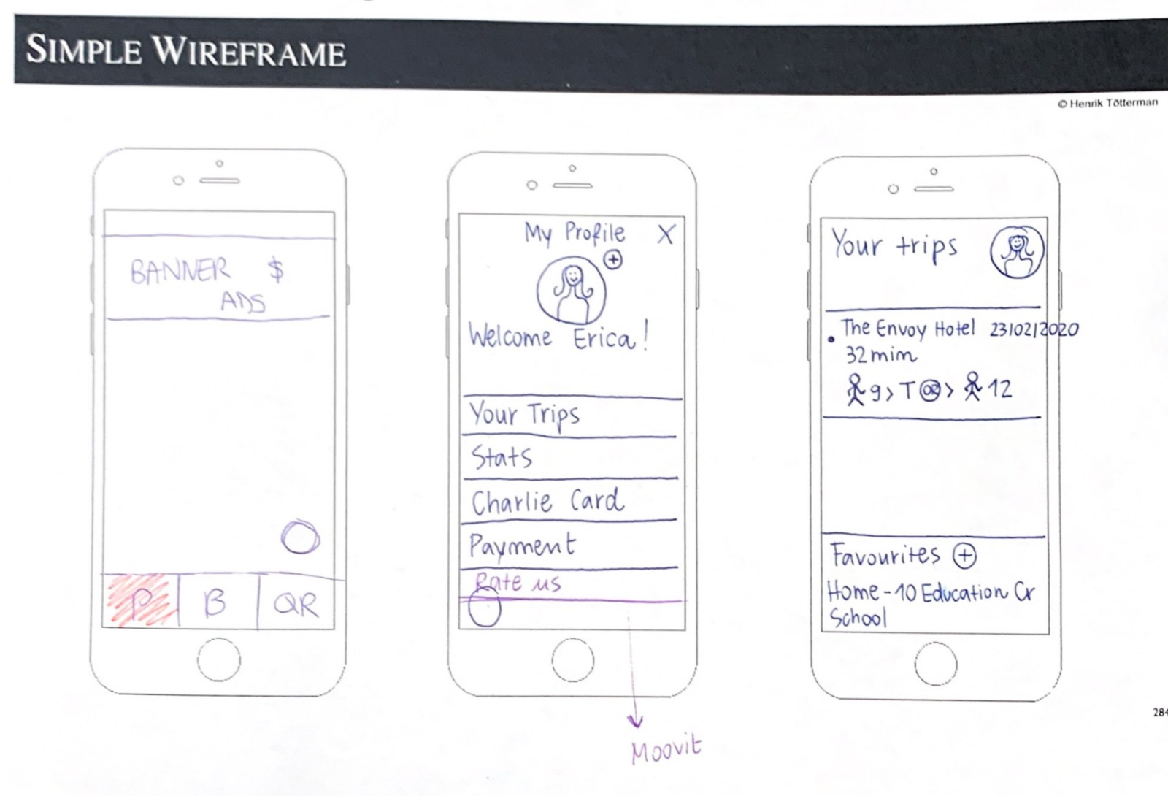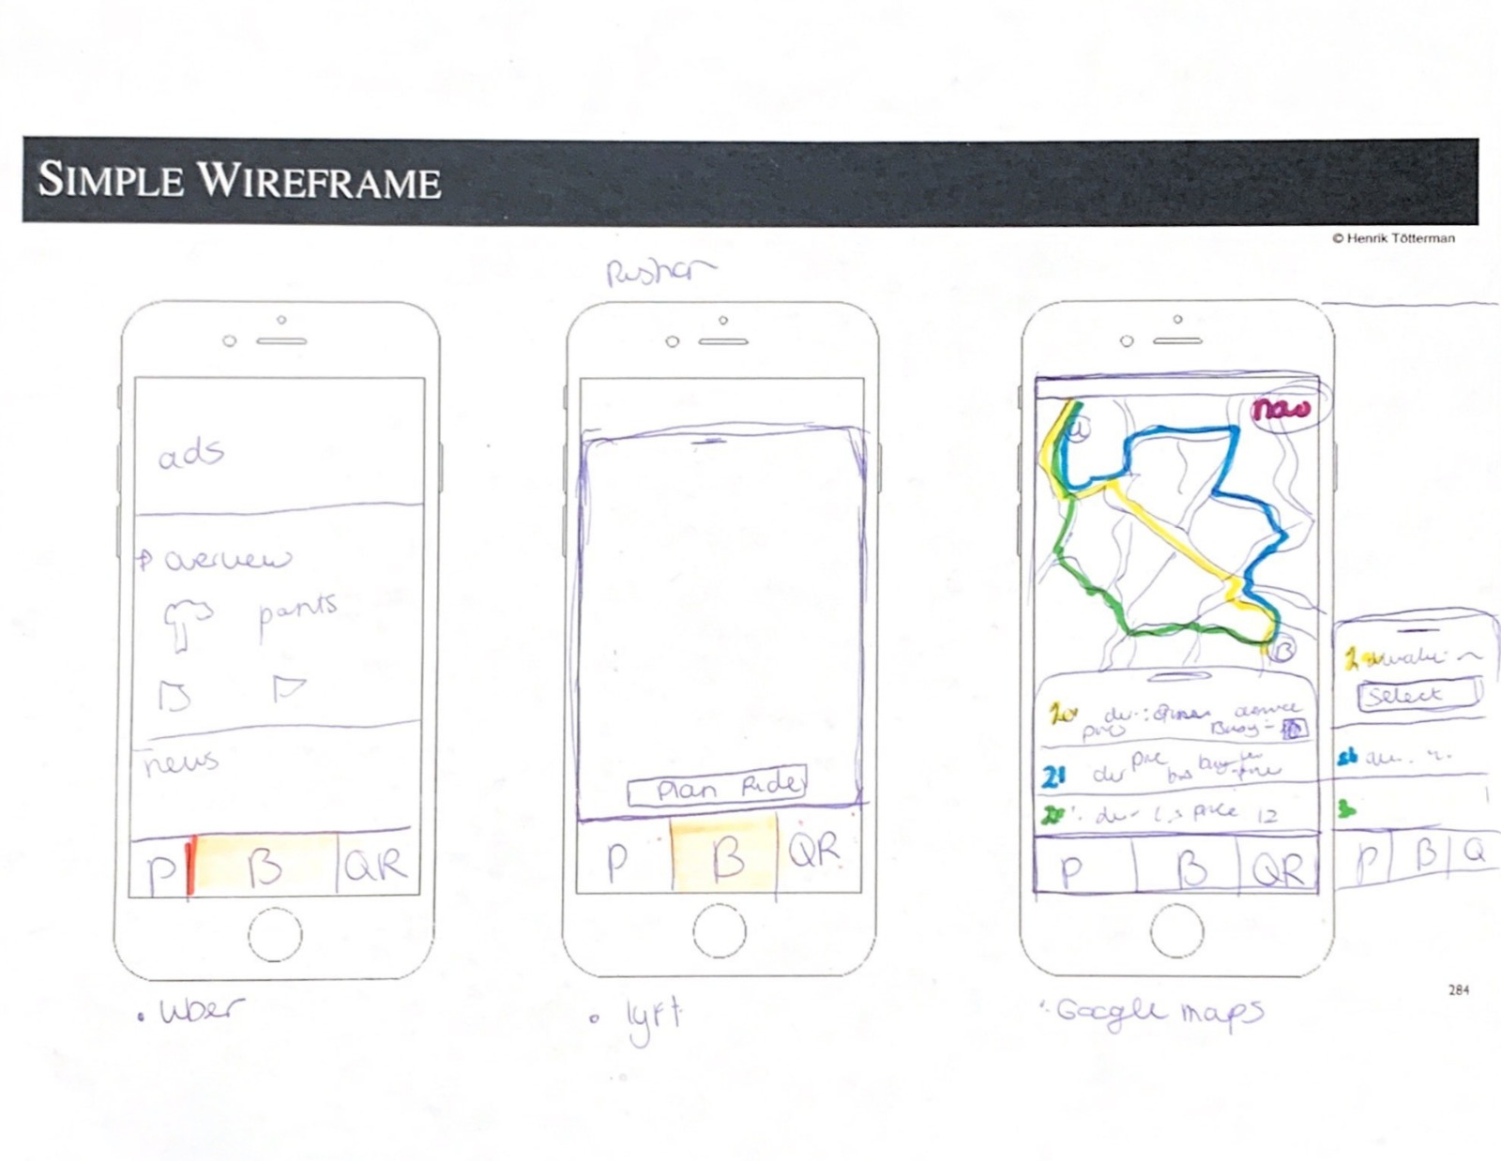

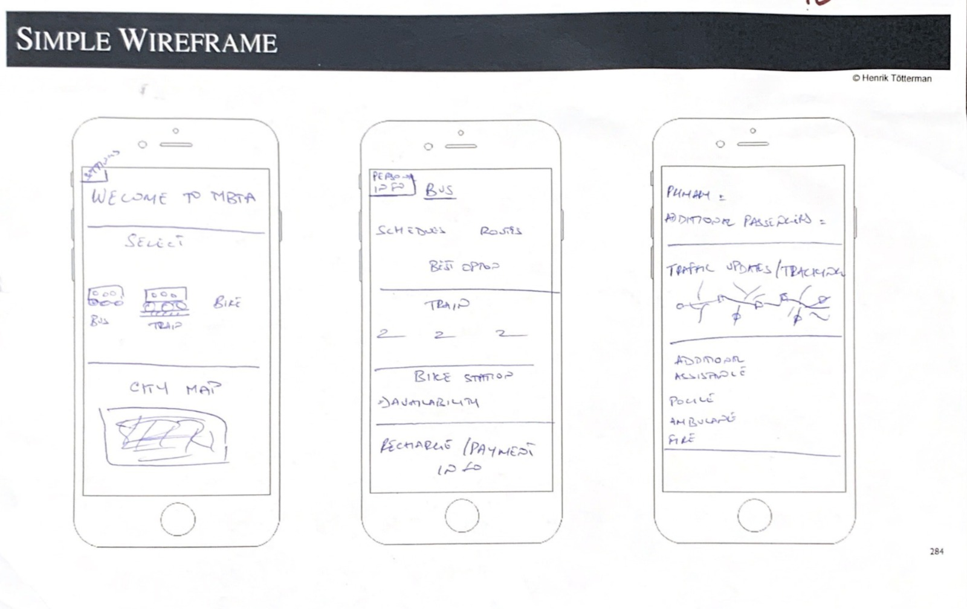

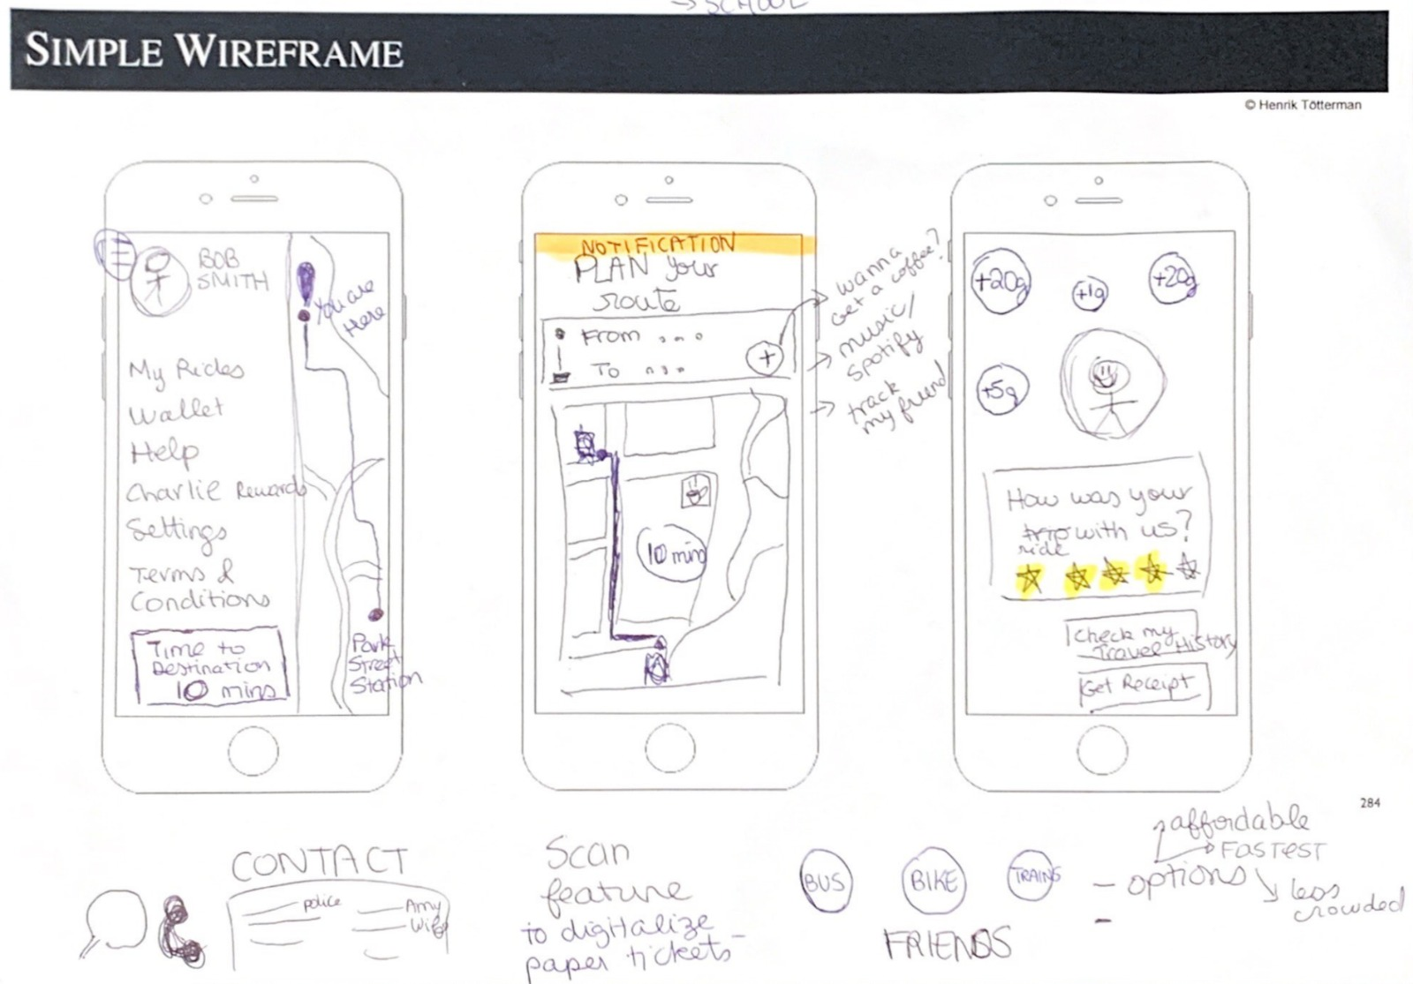

## 

## 

## 

## 

## 

## 

## A screenshot of a cell phone Description automatically generatedAppendix 7 Digital Prototype

## Appendix 8: Dataset_Understanding _Problem

|  |  |  |  |  |  |  |  |  |  |
| --- | --- | --- | --- | --- | --- | --- | --- | --- | --- |
| Age | Occupation | How often do you take public transportation ? | How satisfied are you with the public transportation in MA ? | ? [Price] | Time Reliability (wait time)] | [Customer Service] | [frequency of transportation] | [Number of transfers] | [Ticket Purchase Process] |
| 29-38 | Student | Daily | 3 | Unsatisfied | Unsatisfied | Neutral | Neutral | Neutral | Neutral |
| 23-28 | Student | Weekly | 2 | Neutral | Neutral | Unsatisfied | Neutral | Unsatisfied;Neutral | Unsatisfied |
| 29-38 | Working Professional | Daily | 1 | Neutral | Neutral | Neutral | Neutral | Neutral | Neutral |
| 23-28 | Student | Daily | 4 | Unsatisfied | Neutral | Unsatisfied | Neutral | Satisfied | Satisfied |
| 23-28 | Student | Daily | 2 | Very Unsatisfied | Unsatisfied | Neutral | Unsatisfied | Neutral | Neutral |
| 23-28 | Student | Weekly | 3 | Neutral | Unsatisfied | Unsatisfied | Unsatisfied | Neutral | Neutral |
| 23-28 | Student | Daily | 3 | Neutral | Neutral | Neutral | Neutral | Neutral | Neutral |
| 23-28 | Student | Monthly | 5 | Satisfied | Neutral | Satisfied | Satisfied | Satisfied | Satisfied |
| 29-38 | Student | Daily | 4 | Neutral | Neutral | Neutral | Unsatisfied | Neutral | Neutral |
| 23-28 | Student | Daily | 1 | Neutral | Unsatisfied | Unsatisfied | Unsatisfied | Unsatisfied | Unsatisfied |
| 23-28 | Student | Daily | 3 | Very Unsatisfied | Unsatisfied | Unsatisfied | Unsatisfied | Neutral | Neutral |
| 23-28 | Student | Not often | 3 | Unsatisfied | Neutral | Neutral | Unsatisfied | Neutral | Unsatisfied |
| 23-28 | Student | Monthly | 3 | Unsatisfied | Neutral | Satisfied | Neutral | Neutral | Unsatisfied |
| 23-28 | Student | Daily | 1 | Neutral | Very Unsatisfied | Unsatisfied | Unsatisfied | Unsatisfied | Unsatisfied |
| 23-28 | Student | Daily | 3 | Very Unsatisfied | Unsatisfied | Neutral | Neutral | Neutral | Unsatisfied |
| 21 | Student | Monthly | 1 | Very Unsatisfied | Very Unsatisfied | Unsatisfied | Neutral | Neutral | Unsatisfied |
| 23-28 | Student | Weekly | 2 | Very Unsatisfied | Very Unsatisfied | Very Unsatisfied | Unsatisfied | Very Unsatisfied | Very Unsatisfied |
| 23-28 | Student | Daily | 4 | Very Satisfied | Unsatisfied | Satisfied | Very Unsatisfied | Unsatisfied | Very Satisfied |
| 23-28 | Student | Weekly | 3 | Neutral | Neutral | Neutral | Neutral | Neutral | Unsatisfied |
| 23-28 | Student | Weekly | 3 | Unsatisfied | Unsatisfied | Neutral | Unsatisfied | Neutral | Satisfied |
| 23-28 | Student | Weekly | 4 | Very Satisfied | Neutral | Satisfied | Satisfied | Satisfied | Very Satisfied |
| 23-28 | Student | Monthly | 2 | Neutral | Very Unsatisfied | Unsatisfied | Very Unsatisfied | Unsatisfied | Unsatisfied |
| 23-28 | Student | Monthly | 3 | Neutral | Neutral | Neutral | Neutral | Neutral | Neutral |
| 29-38 | Student | Daily | 3 | Unsatisfied | Unsatisfied | Unsatisfied | Unsatisfied | Satisfied | Satisfied |
| 21 | Student | Weekly | 3 | Satisfied | Neutral | Neutral | Satisfied | Unsatisfied | Neutral |
| 23-28 | Student | Daily | 3 | Unsatisfied | Satisfied | Neutral | Neutral | Satisfied | Satisfied |
| 23-28 | Student | Monthly | 2 | Unsatisfied | Unsatisfied | Neutral | Neutral | Neutral | Neutral |
| 23-28 | Student | Daily | 4 | Satisfied | Satisfied | Satisfied | Satisfied | Neutral | Neutral |
| 29-38 | Working Professional | Daily | 3 | Unsatisfied | Very Unsatisfied | Very Unsatisfied | Unsatisfied | Satisfied | Satisfied |
| 20 | Student | Daily | 4 | Very Unsatisfied | Satisfied | Satisfied | Satisfied | Satisfied | Satisfied |
| 23-28 | Working Professional | Monthly | 3 | Very Unsatisfied | Unsatisfied | Very Unsatisfied | Unsatisfied | Neutral | Very Unsatisfied |
| 22 | Student | Monthly | 2 | Satisfied | Unsatisfied | Satisfied | Unsatisfied | Neutral | Satisfied |
| 29-38 | Working Professional | Weekly | 4 | Satisfied | Neutral | Neutral | Satisfied | Satisfied | Very Unsatisfied |
| 51 | Working Professional | Monthly | 3 | Satisfied | Satisfied | Neutral | Satisfied | Neutral | Unsatisfied |
| 35+ | Working Professional | Daily | 1 | Unsatisfied | Unsatisfied | Unsatisfied | Unsatisfied | Unsatisfied | Unsatisfied |
| 29-38 | Student | Daily | 3 | Unsatisfied | Unsatisfied | Unsatisfied | Unsatisfied | Satisfied | Satisfied |
| 23-28 | Working Professional | Almost never | 3 | Neutral | Satisfied | Satisfied | Satisfied | Satisfied | Satisfied |
| 23-28 | Working Professional | Monthly | 4 | Satisfied | Satisfied | Neutral | Neutral | Satisfied | Very Satisfied |
| 29-38 | Working Professional | Daily | 3 | Neutral | Unsatisfied | Satisfied | Neutral | Satisfied | Satisfied |
| 23-28 | Student | Monthly | 3 | Unsatisfied | Unsatisfied | Satisfied | Neutral | Neutral | Satisfied |
| 29-38 | Student | Weekly | 3 | Neutral | Satisfied | Very Satisfied | Unsatisfied | Neutral | Satisfied |
| 23-28 | Student | Daily | 2 | Neutral | Very Unsatisfied | Neutral | Very Unsatisfied | Neutral | Very Unsatisfied |
| 23-28 | Student | Daily | 2 | Neutral | Very Unsatisfied | Neutral | Very Unsatisfied | Neutral | Very Unsatisfied |
| 23-28 | Student | Weekly | 3 | Unsatisfied | Satisfied | Neutral | Neutral | Neutral | Neutral |
| 23-28 | Student | Monthly | 2 | Neutral | Neutral | Neutral | Neutral | Neutral | Neutral |
| 35+ | Working Professional | Weekly | 3 | Very Unsatisfied | Unsatisfied | Unsatisfied | Unsatisfied | Unsatisfied | Neutral |
| 23-28 | Student | Weekly | 1 | Very Unsatisfied | Very Unsatisfied | Very Unsatisfied | Very Unsatisfied | Very Unsatisfied | Very Unsatisfied |
| 23-28 | Student | Daily | 1 | Unsatisfied | Very Unsatisfied | Very Unsatisfied | Very Unsatisfied | Very Unsatisfied | Neutral |

## Appendix 9 Observations / Experiences

Name observer: Estrella Spaans

Date: 12/19/2018

Location: Online / South Station

Provider: Amtrak

Observation: Tickets can be easily purchased online on either the application. You can choose your time, the class you want to travel, and the date. You pay for your ticket, and you will get an e-ticket. I took an uber to South Station as I did not want to risk being late for boarding time due to the unreliable system of the MBTA, the uber is quite expensive, but that is the sacrifice I had to make. At the station, I noticed that all the trains scheduled were on time. When the train arrived, I could board without checking in. Only later during the ride, the tickets were checked. The facilities were good, and free Wi-Fi was available. Without delays, I arrived at Penn Station, NY.

___________________________________________________________________________

Name observer: Estrella Spaans

Date: 02/24/2020

Location: Allston

Provider: MBTA

Observation: I observed that in the non-city center areas, there are not many ticket machines, people have to go to the stores to get tickets or buy them online. The store’s customer service was not open after 9 PM, which made it impossible to update my card’s balance.

__________________________________________________________________________

Name observer: Estrella Spaans

Date: 12/19/2019

Location: Online

Provider: MBTA

Observation: I saw that it was possible to buy tickets online to update my Charlie card. I visited the <https://www.mbta.com/> website, which directed me to <https://charliecard.mbta.com/>. There are four steps in this process. First, I had to enter the detail of my Charlie Card. Then I could choose the value I wanted to add to my card. Then I had to fill in the billing address. The last step is a confirmation; however, the balance would update in 2-3 days.

___________________________________________________________________________

Name observer: Estrella Spaans

Date: 12/19/2019

Location: South Station

Provider: Peter Pan Bus Lines

Observation: The tickets begin online, or you can buy them at the customer service in South Station. In my opinion, the tickets to Cape Cod were relevantly expensive ($25). I had to take the green and red line (which had left too early) to get to the station. Once arrived, there are waiting for seat assignment for certain destinations. Before entering the bus, the chauffeur asked for the tickets and your destination. There was Wi-Fi. The bus arrived ahead of schedule; therefore, I had to wait longer outside for my next connection in Hyannis, MA.

__________________________________________________________________________

Name of observer: Ruisheng Wang

Date:02/20/20

Location: Malden, Boston University, Downtown Crossing, Park street

Provider: MTBA

Observation: Not every station can get the Charlie card. Only big stations are allowed to get the Charlie card. If the tourists or the people who first time come to Boston cannot get the card. The people want to take the train from Malden to Boston University, they need to take the orange line to downtown crossing, check out, then walk to Park Street and buy the ticket and check in again which means they need to pay twice for the whole journey.

___________________________________________________________________________

Name of observer: Ruisheng Wang

Date: 02/23/20

Location: Copley, community college

Provider: MTBA

Observation: The people in Copley enter the wrong side, when they want to change the opposite line, they need to check out and buy the tickets again to check in. The train stops and waits quiet often for some reason. Rush hour is super crowed and wait 6-8 mins to wait the next train coming. Not rush time like 7:30, two trains coming together within 3 mins with available seats.

___________________________________________________________________________

Name of observer: Ruisheng Wang

Date: 03/01/20

Location: Harvard Square

Provider: MTBA

Observation: Google real time is not reliant and cannot see the bus when it shows it arrives. 3 buses pass according to google, but no bus show up.

___________________________________________________________________________

Name of observer: Ruisheng Wang

Date: 12/27/19

Location: South Station, on the way to New York

Provider: Amtrak

Observation: For the train for state, they use the traditional way to check the tickets by people with flag and if you take the digital tickets, when the signal is not good, you cannot open the QR code when it is running on the railway.

|  |  |  |  |  |  |  |  |  |  |  |  |
| --- | --- | --- | --- | --- | --- | --- | --- | --- | --- | --- | --- |
|  |  | *Designed for:* | | | | | *Designed by:* | | *Date:* | | *Version:* |
| **Business Model Canvas** | | U-Go | | |  | | Team 10 |  | 3/9/2020 |  | 1 |
|  |  |  | | | | |  | |  | | |
| **Key Partners** | **Key Activities** | | **Value Propositions** | | | **Customer Relationships** | | | **Customer Segments** | | |
| Mass Transportation  MBTA  Private Providers  Data Companies | * Marketing * App maintenance * Operations * Human Resources * Business Development * Data Analysis | | “For travelers that want a seamless public transportation experience, U-Go powered by Verizon, integrates the regional transportation services to create easy access, personalized travel-routes, and real-time updates adjusted to your needs.” | | | | Loyalty Program  CSR Program | | Students  Working professionals  Tourist | | |
| **Key Resources**  Verizon Product Portfolio  (Subsidiary)   * Financial * Human * Tangible * Intangible | | **Channels**  Mobile Application  Providers  Stations / stops | |
|  | |  | |
| **Cost Structure** | | | | **Revenue Streams (ROI)** | | | | | | | |
| One-Time Investment   * 5G-enabled Equipment * Scanners * Application Development Costs   Data- Management  Application Updates | | | | Related – Advertisements  Fee on top of generated price  Open Sourcing (Verizon) | | | | | | | |
|  | | | | | | | | | | | |

## Appendix 10 The Business Model Canvas.

## Appendix 11 Personas

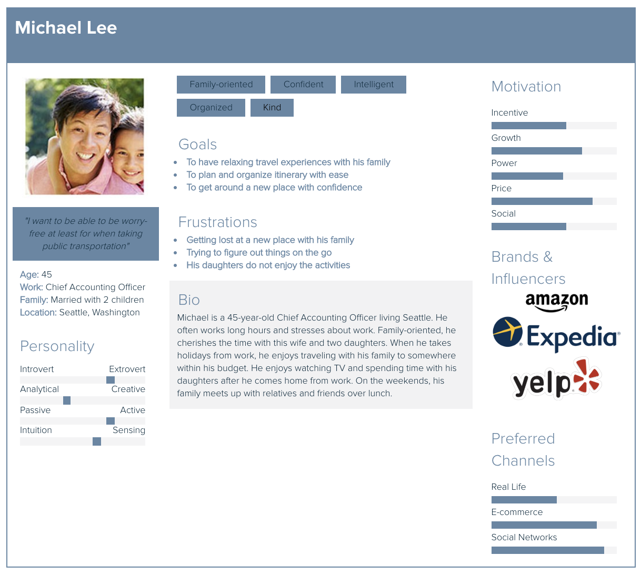

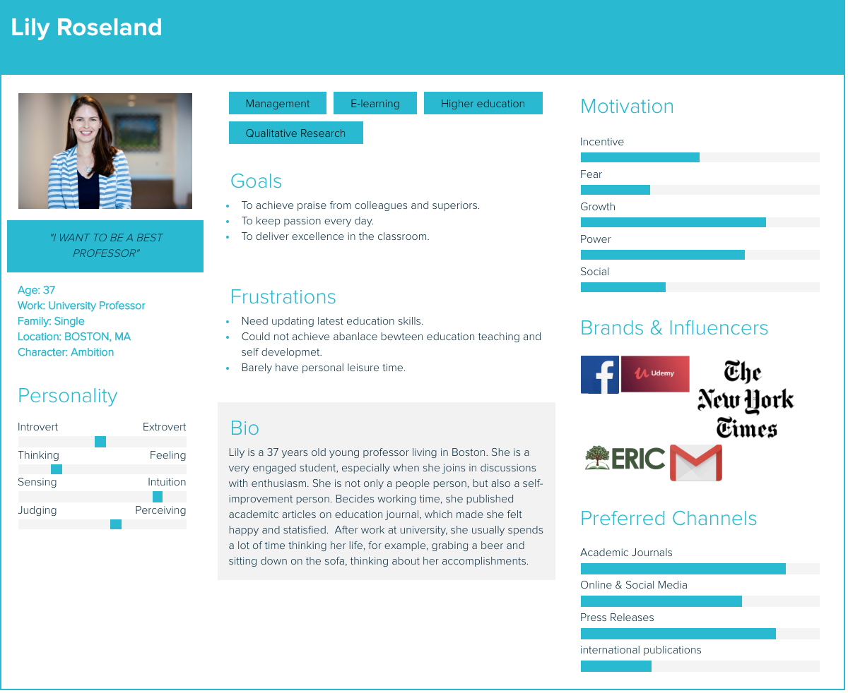

## Appendix 12 Customer Journey

|  |  |  |  |  |  |  |  |  |  |  |  |  |
| --- | --- | --- | --- | --- | --- | --- | --- | --- | --- | --- | --- | --- |
| **Initiation of Relationship** | | | | | | **Cultivation of Relationship** | | | | **Dissolution of Relationship** | | |
|  | | | | | |  | | | |  | | Rate us / trip  Use Again! |
|  | | | | | |  | | | |  | Green commuter rewards & Receipt |  |
|  | | | | | |  | | | Arrived at destination on time. Feels relaxed and satisfied | |  | |
|  | | | | Scan my e-ticket (QR-code) on the check in scanner | | |  | Notification of the trip, personalized offers, and entertainment during the trip |  |  | | |
|  | | | Plan my ride | |  |  | Checks if the trip information given is accurate |  | |  | | |
|  | | Create an account on the app. Enter profile, payment details |  | | |  | | | |  | | |
|  | Scan Advertisement QR code to download the app |  | | | |  | | | |  | | |
| Billboard Advertisements In public transportation areas |  | | | | |  | | | |  | | |

Pink = Actions within the application, Orange = Offline actions

## Appendix 13 Estimated Return on Investment

|  |  |  |  |  |  |
| --- | --- | --- | --- | --- | --- |
| **First Year** | **Revenue** | **Second Year** |  | **Third Year** |  |
| Assumption 5% of each ride | 92,710,000.00 | Assumption 5% of each ride | 92,710,000.00 | Assumption 5% of each ride | 92,710,000.00 |
| Assumption 10% passengers use the app | 9,271,000.00 | Assumption 15% passengers use the app | 13,906,500.00 | Assumption 20% passengers use the app | 18,542,000.00 |
|  | **Cost** |  |  |  |  |
| Investment of Application | 478,000 |  |  |  |  |
| Investment of Devices |  |  |  |  |  |
| Low Cost Scenario | 10,000,000 |  |  |  |  |
| high Cost Scenario | 15,000,000 |  |  |  |  |
|  | **Cost in total** |  |  |  |  |
| Low Cost in total | 10,478,000 |  |  |  |  |
| High Cost in total | 15,478,000 |  |  |  |  |
|  |  |  |  |  |  |
| Profit of Low-Cost Scenario | (1,207,000.00) | Profit of Low-Cost Scenario | 3,428,500 | Profit of Low-Cost Scenario | 8,064,000.00 |
| **ROI Rate of Low-Cost Scenario** | -12% | **ROI Rate of Low Cost Scenario** | 33% | **ROI Rate of Low-Cost Scenario** | 77% |
| Profit of High Cost Scenario | (6,207,000.00) | Profit of High Cost Scenario | -1,561,500 | Profit of High Cost Scenario | 3,064,000.00 |
| **ROI Rate of High Cost Scenario** | -40% | **ROI Rate of High Cost Scenario** | -10% | **ROI Rate of High Cost Scenario** | 20% |

## Appendix 14 Prototype Benchmarking

|  |  |  |
| --- | --- | --- |
| Image result for google Map UX directions  **Google Maps** | Image result for UX design QR code  **QR Code by Guillaume Marc** | **Image result for loyalty program ux designLoyalty Program by Angie Ochao** |
| **Image result for uber rate ride**  **Uber** | **Uber** | **Lyft** |

## Appendix 15 Transcripts Focus Group Testing Prototype

### Focus Group 1 (Audio file 1)

**Team 10** ([00:01](https://www.temi.com/editor/t/9gj_BPbEB6ZJJ6NMhwpyPFqwQ6gViJZtWJtOvyY4OtJuIUjGcmGduegIqoKocNK2pUy9urWlAue-WJh3alKnY54jMAg?loadFrom=DocumentDeeplink&ts=1.29)): One of the problems we identified in our research is that if you're going from Boston to Rhode Island or Boston to Cape Cod, you need to use different apps. So that's one of the problems. So, if you guys would have to solve this problem. How would you solve it? Like how would you make it better? What do you think should be made? Which features do you think should be made better?

**Respondent** ([00:26](https://www.temi.com/editor/t/9gj_BPbEB6ZJJ6NMhwpyPFqwQ6gViJZtWJtOvyY4OtJuIUjGcmGduegIqoKocNK2pUy9urWlAue-WJh3alKnY54jMAg?loadFrom=DocumentDeeplink&ts=26.85)): For private companies that they used it but like for the public transportation it's the government. So that's why it's different in my opinion is like they have to collaborate with the private companies and public. Yeah. That's how they can read the app and use it to get, so I would create an app and *I would collaborate with public and private transportation.*

**Team 10** ([00:55](https://www.temi.com/editor/t/9gj_BPbEB6ZJJ6NMhwpyPFqwQ6gViJZtWJtOvyY4OtJuIUjGcmGduegIqoKocNK2pUy9urWlAue-WJh3alKnY54jMAg?loadFrom=DocumentDeeplink&ts=55.13)): So that is pretty much the solution that we have done as well. So, we have integrated the 15 different types of public transportation and private transportation systems into one single application, that gives you real time updates about the buses and trains coming nearby your location. For instance, currently if you take the bus in Massachusetts and it says that is coming in three minutes, the buses come around five minutes sometimes or two minutes. The accuracy it’s the main pain point in this situation.

Therefore, our solution mixes several technologies together, like a sensor inside public and private buses and trains in Massachusetts that using 5G and the Internet of Thing (IoT) shows commuters the exact waiting timing nearby their location.

Additionally, inside our app named U-Go you can buy e-tickets instead of kiosks inside T stations. First, you have to download our App, available in iOS and Google Play. Create an account, set up your profile. Then, add your payment method and now you will have a Digital Charlie Card.

Now, all you need to do is load your money and scan your phone in the entrance and go. After each ride you will collect *“Green Commuter Rewards”* that users can redeem for coffee at Starbucks or a free sandwich at Panera bread or free rides. Now, we will show you guys the video of our demo prototype.

### Focus Group 1 (Audio file 2)

([00:00](https://www.temi.com/editor/t/D_RK_iUdHH8QNDtjTAl6RdVItaUo0-2hZ_tjpFT1XN6gTrN4WIm4Tn-moDW86KgIhhKnrsH9O5gvK2yWE9xq8MWWw3M?loadFrom=DocumentDeeplink&ts=0.35)): So having watched this, will you use this app?

**Respondent** ([00:04](https://www.temi.com/editor/t/D_RK_iUdHH8QNDtjTAl6RdVItaUo0-2hZ_tjpFT1XN6gTrN4WIm4Tn-moDW86KgIhhKnrsH9O5gvK2yWE9xq8MWWw3M?loadFrom=DocumentDeeplink&ts=4.02)): For sure. It's very convenient.

**Team 10** ([00:05](https://www.temi.com/editor/t/D_RK_iUdHH8QNDtjTAl6RdVItaUo0-2hZ_tjpFT1XN6gTrN4WIm4Tn-moDW86KgIhhKnrsH9O5gvK2yWE9xq8MWWw3M?loadFrom=DocumentDeeplink&ts=5.22)): So what we want to provide to U-Go users is to skip steps like having to open the app, instead we want them just to open their camera and scan the QR code which will visualize the app in real time giving you relevant information and visualize it so you can always be on time to your final destination. Wherever you are within the Massachusetts area.

Also, it will give commuter recommendations of trendy and touristic restaurants, museums and coffee shops part of our *Key Partners Program*. So, U-Go will let you know if buses or trains are coming in 10 minutes but in case you want to grab a cup of Starbucks you can stop by and it will delay your arrival type by X number of minutes.

The best part about U-Go is that you can redeem “Green Commuter Rewards” if none of our suggestions are appealing to users, they can always get free rides as well. This way we incentivize the use of public transportation and our App while give our loyal users something back that is customized to their preferences. So, would you guys use U-Go App?

**Respondent** ([00:47](https://www.temi.com/editor/t/D_RK_iUdHH8QNDtjTAl6RdVItaUo0-2hZ_tjpFT1XN6gTrN4WIm4Tn-moDW86KgIhhKnrsH9O5gvK2yWE9xq8MWWw3M?loadFrom=DocumentDeeplink&ts=47.61)): For sure. Sure. Definitely.

**Team 10** ([00:58](https://www.temi.com/editor/t/D_RK_iUdHH8QNDtjTAl6RdVItaUo0-2hZ_tjpFT1XN6gTrN4WIm4Tn-moDW86KgIhhKnrsH9O5gvK2yWE9xq8MWWw3M?loadFrom=DocumentDeeplink&ts=58.22)): Do you have any feedbacks, like something that you maybe will add?

**Respondent** ([01:03](https://www.temi.com/editor/t/D_RK_iUdHH8QNDtjTAl6RdVItaUo0-2hZ_tjpFT1XN6gTrN4WIm4Tn-moDW86KgIhhKnrsH9O5gvK2yWE9xq8MWWw3M?loadFrom=DocumentDeeplink&ts=63.48)): Maybe a feature for the flights and buy flight tickets?

**Team 10** ([01:08](https://www.temi.com/editor/t/D_RK_iUdHH8QNDtjTAl6RdVItaUo0-2hZ_tjpFT1XN6gTrN4WIm4Tn-moDW86KgIhhKnrsH9O5gvK2yWE9xq8MWWw3M?loadFrom=DocumentDeeplink&ts=68.29)): Okay, sure. Thank you for your feedback. Right now, we are starting with buses and trains. Also, private systems, like Peter pan. We can see how flights could be incorporated in the future.

Thank you for your time.

### Focus Group 2 (Audio File 3)

**Team 10** ([00:00](https://www.temi.com/editor/t/TFnO_y43WC7KSYZtLjQPX8w3Z5oalRtHtrOHy61S-VVeejcz9s1yIJTlFKCJAebQnDrvW_5AxUK-w8q5JhPLbfyksgY?loadFrom=DocumentDeeplink&ts=0.24)): There is five different apps in the public and private transportation system in Massachusetts. So, the frequency and timings of the buses and trains are not accurate. Additionally, they don't track and show you in an integrated way how you can arrive to your destination in the “fastest” or “cheapest” way.

There’s also the recharging problem with the Charlie card. Since there is a lack of a digital version making payments sometimes is restricted to offices hours. We want to find out if the current consumer prefers to have 24/7 service with our live chat feature.

So, in case you travel inside Massachusetts, you just have one transit solution, the U-Go App. No more problems like the bus saying it will come in nine minutes and having to wait longer. So, as commuters, what would you want to solve? How would you solve these problems? If you were giving this assignment, what do you think it would be a solution for this problem?

**Respondents** ([01:51](https://www.temi.com/editor/t/TFnO_y43WC7KSYZtLjQPX8w3Z5oalRtHtrOHy61S-VVeejcz9s1yIJTlFKCJAebQnDrvW_5AxUK-w8q5JhPLbfyksgY?loadFrom=DocumentDeeplink&ts=111.48)): I mean, probably an app. I think everybody uses apps today, so everybody's on their phones. Uh, so it's probably easy and that there should be a way of integrating all the, you know, information from the different, uh, you know, whoever is managing those apps tried to, I don't know if getting it together and see if they can find a solution or I mean in the worst case, a middle person that like gathers the information and makes just one unified up for the people,

**Team 10** ([02:28](https://www.temi.com/editor/t/TFnO_y43WC7KSYZtLjQPX8w3Z5oalRtHtrOHy61S-VVeejcz9s1yIJTlFKCJAebQnDrvW_5AxUK-w8q5JhPLbfyksgY?loadFrom=DocumentDeeplink&ts=148.19)): What would you like to see within the app?

**Respondents** ([02:30](https://www.temi.com/editor/t/TFnO_y43WC7KSYZtLjQPX8w3Z5oalRtHtrOHy61S-VVeejcz9s1yIJTlFKCJAebQnDrvW_5AxUK-w8q5JhPLbfyksgY?loadFrom=DocumentDeeplink&ts=150.53)): Well, right times, you know, cause for example, I have the Apple and if you choose public transport, like I sometimes look at it and it says like, Oh, your bus will arrive in eight minutes, but it doesn’t. It's not arriving. They do have the right timing in the stations. So, there should be a way that the information from the stations is connected to your phone at some point.

Uh, but also some, sometimes, you know, the bus is not that kind of correct. The time. I mean the timing is not correct. Last time I went to Harvard for the bus and Google just told me, okay, the bus is coming. And 30 minutes later, there was still no bus. I actually had the same. I was getting out Boston to go to Boston Logan airport with the shuttle and I was waiting for it. It said it was going to arrive like in 10 minutes and it took more, you know, and then you don't know, you're like, okay, did I miss it?

**Team 10** ([04:15](https://www.temi.com/editor/t/TFnO_y43WC7KSYZtLjQPX8w3Z5oalRtHtrOHy61S-VVeejcz9s1yIJTlFKCJAebQnDrvW_5AxUK-w8q5JhPLbfyksgY?loadFrom=DocumentDeeplink&ts=255.301)): Exactly. That’s why we designed this experiment to do more exploratory research and to get feedback on how we can improve our demo video.

### Focus Group 3 (Audio File 4)

**Respondents** ([00:00](https://www.temi.com/editor/t/Xp2LJA6kQW3seLqbb85BxaTCdUFkaz6wCUUeO4CklIGC23-dE6CWP2ivR_hG7G2jcacVGGUhEbAGhDTl0y-vjGqNhxI?loadFrom=DocumentDeeplink&ts=0.36)): Like the new orange line and green line train, all those different unified everything into one platform just like you said.

**Team 10** ([00:10](https://www.temi.com/editor/t/Xp2LJA6kQW3seLqbb85BxaTCdUFkaz6wCUUeO4CklIGC23-dE6CWP2ivR_hG7G2jcacVGGUhEbAGhDTl0y-vjGqNhxI?loadFrom=DocumentDeeplink&ts=10.42)): Then it tells you the minutes and we will have different route options: like the best route, the cheapest way or the fastest way and the user chooses.

**Respondents** ([00:21](https://www.temi.com/editor/t/Xp2LJA6kQW3seLqbb85BxaTCdUFkaz6wCUUeO4CklIGC23-dE6CWP2ivR_hG7G2jcacVGGUhEbAGhDTl0y-vjGqNhxI?loadFrom=DocumentDeeplink&ts=21.39)): Will it tell you for example if I'm here how much, how would it, how much would it take walking to get to the station so I know if I can make it on time?

**Team 10** ([00:28](https://www.temi.com/editor/t/Xp2LJA6kQW3seLqbb85BxaTCdUFkaz6wCUUeO4CklIGC23-dE6CWP2ivR_hG7G2jcacVGGUhEbAGhDTl0y-vjGqNhxI?loadFrom=DocumentDeeplink&ts=28.96)): Yeah and then the cool thing in our prototype is that once you complete your public transportation ride. U-Go will give users “Green Commuter Rewards”.

**Respondents** ([00:49](https://www.temi.com/editor/t/Xp2LJA6kQW3seLqbb85BxaTCdUFkaz6wCUUeO4CklIGC23-dE6CWP2ivR_hG7G2jcacVGGUhEbAGhDTl0y-vjGqNhxI?loadFrom=DocumentDeeplink&ts=49.53)): So it will be kind of like rewarding you for taking public transportation?

**Team 10** ([00:53](https://www.temi.com/editor/t/Xp2LJA6kQW3seLqbb85BxaTCdUFkaz6wCUUeO4CklIGC23-dE6CWP2ivR_hG7G2jcacVGGUhEbAGhDTl0y-vjGqNhxI?loadFrom=DocumentDeeplink&ts=53.47)): Yeah, that's it. It shows you how much you're C02 emissions you are saving and based on your location data offer you products or services from our key partners or free rides.

Additionally, we will show U-GO users display banner ads in the app with special promotions and information based on their preferences. For example, you can exchange your rewards for a cappuccino at Starbucks or get free rides to your next destination.

**Respondents** ([01:17](https://www.temi.com/editor/t/Xp2LJA6kQW3seLqbb85BxaTCdUFkaz6wCUUeO4CklIGC23-dE6CWP2ivR_hG7G2jcacVGGUhEbAGhDTl0y-vjGqNhxI?loadFrom=DocumentDeeplink&ts=77.16)): I think that is a very cool idea. Like you know if you're getting your Charlie card in your phone and just like when you pay, you put your phone kind of like Apple Pay, you know, something like that. You just tap it and it charges.

**Team 10** ([01:29](https://www.temi.com/editor/t/Xp2LJA6kQW3seLqbb85BxaTCdUFkaz6wCUUeO4CklIGC23-dE6CWP2ivR_hG7G2jcacVGGUhEbAGhDTl0y-vjGqNhxI?loadFrom=DocumentDeeplink&ts=89.76)): Yeah, that was the idea behind U-Go. Also, aside your reward points which you're trying to redeem. It also shows as part of our CSR efforts how much C02 you reduced by using our suggested routes. Because each person when taking a car create certain footprint so by using public transportation you are contributing to reduce pollution in general.

U-Go is incentivizing commuters that instead of taking an Uber or Lyft. Use U-Go and take the public transportation while getting rewards like free drinks at your nearest coffee shop once you complete X number of rides.

**Respondents** ([01:57](https://www.temi.com/editor/t/Xp2LJA6kQW3seLqbb85BxaTCdUFkaz6wCUUeO4CklIGC23-dE6CWP2ivR_hG7G2jcacVGGUhEbAGhDTl0y-vjGqNhxI?loadFrom=DocumentDeeplink&ts=117.73)): Another thing that is important here in Boston is that the people actually is very used to take public transportation. The system is not nice. It's like a cultural thing here to take the train. So many people actually prefer it because there are many students in town. You cannot compare it to cities like in Latin America.

**Team 10** ([02:25](https://www.temi.com/editor/t/Xp2LJA6kQW3seLqbb85BxaTCdUFkaz6wCUUeO4CklIGC23-dE6CWP2ivR_hG7G2jcacVGGUhEbAGhDTl0y-vjGqNhxI?loadFrom=DocumentDeeplink&ts=145.241)): So would you use this app if it becomes a reality?

**Respondents** ([02:25](https://www.temi.com/editor/t/Xp2LJA6kQW3seLqbb85BxaTCdUFkaz6wCUUeO4CklIGC23-dE6CWP2ivR_hG7G2jcacVGGUhEbAGhDTl0y-vjGqNhxI?loadFrom=DocumentDeeplink&ts=145.241)): Yes. Definitely.

## Focus Group 4 (Audio File 5)

**Team 10** ([00:00](https://www.temi.com/editor/t/-SwDLNsIJWDlTYgZRiwRMV9Ncpkem30yYvUtRodhYiZ-YUvJeGKl1dZ1K6mE9ifc7Hx1jQTO983DVomwqaWUGcT5SXg?loadFrom=DocumentDeeplink&ts=0.2)): What service in Massachusetts public transportation you think should be made to better your everyday life? And, if you had this problem, how would you solve it? What would you do to make the current public transportation system better in Massachusetts?

**Respondents** ([00:17](https://www.temi.com/editor/t/-SwDLNsIJWDlTYgZRiwRMV9Ncpkem30yYvUtRodhYiZ-YUvJeGKl1dZ1K6mE9ifc7Hx1jQTO983DVomwqaWUGcT5SXg?loadFrom=DocumentDeeplink&ts=17.28)): In an ideal world I would create a lane for the buses. So, I just, I use the bus mostly. So, it’s all in one lane. And then also like departure points depending on the amount of people. For example, there's a lot of buses coming before my stop that are empty. But then when you get closer to school, they're so freaking crowded.

So, why do we have to wait? Like beyond having more buses, they should start further down and have less amount of people in every bus. Like, uh, also you have to check the times that people normally leave and use those buses because there's sometimes like they, they don't come for like an hour, but there's people that need it.

So, you can do it like close to the same frequency. And then what else? Like I think the main thing is the same lane cause a lot people would use it if there was just a lane because you know you will be on time. For example, the one I sometimes use to go to Sullivan has its own lane for one of the streets for Broadway and that helps. I mean that would be for like for me the best thing.

The main difference in my hometown is that where I live the train is automated. So, like it's always come at the right time. If there is an accident or some changes, everything is automated. So, there's no human.

Also, for example, there's too many stops. So, if you go in into the app, there's too many stops, like together, this is the app I use. Look at this street. Yeah. Why do you have so many stops? Like make people walk a bit. So that's like really inconvenient. If there's so many stops, for example, sometimes you see this, and you can predict how long it will take. But sometimes it loses connection. So, you really don't know when to go out and you don't know if it's going to take the bus more to go from here to here than from here to here. So, I mean also I do think that in some ways the stoplights should be like, um, synchronized with the bus.

**Team 10** ([03:22](https://www.temi.com/editor/t/-SwDLNsIJWDlTYgZRiwRMV9Ncpkem30yYvUtRodhYiZ-YUvJeGKl1dZ1K6mE9ifc7Hx1jQTO983DVomwqaWUGcT5SXg?loadFrom=DocumentDeeplink&ts=202.02)): Mm. Okay. Interesting. Okay. So, we were going to show you the prototype that we have. The solution that we created. It’s called U-Go. So basically, it's an app that you will first create an account. So, you can create your profile, add your picture and then you put your payment.

So, then you will go to the T station or the bus and instead of having a Charlie card, it would be a digital Charlie card. Like if you are in the bus station, you just take out your camera and scan the QR code and it triggers the app, so it saves you time and then if you have questions you will have a live chat or you can call someone in case of an emergency. Then, you will put where you want to go, and U-Go will give you different options for routes. Like what is the cheapest way, what is the fastest way. Once you select your route. We will use 5G technology to give accurate waiting times. There’s also the QR code part.

**Respondents** ([05:13](https://www.temi.com/editor/t/-SwDLNsIJWDlTYgZRiwRMV9Ncpkem30yYvUtRodhYiZ-YUvJeGKl1dZ1K6mE9ifc7Hx1jQTO983DVomwqaWUGcT5SXg?loadFrom=DocumentDeeplink&ts=313.52)): So what does the QR actually do?

**Team 10** ([05:17](https://www.temi.com/editor/t/-SwDLNsIJWDlTYgZRiwRMV9Ncpkem30yYvUtRodhYiZ-YUvJeGKl1dZ1K6mE9ifc7Hx1jQTO983DVomwqaWUGcT5SXg?loadFrom=DocumentDeeplink&ts=317.181)): Is for payment. That is the main point because you don't want to use the Charlie Card anymore because you will scan the QR code and login to your account and check your e-Charlie card. You can both check your travel data in your phone.

**Respondents** ([05:37](https://www.temi.com/editor/t/-SwDLNsIJWDlTYgZRiwRMV9Ncpkem30yYvUtRodhYiZ-YUvJeGKl1dZ1K6mE9ifc7Hx1jQTO983DVomwqaWUGcT5SXg?loadFrom=DocumentDeeplink&ts=337.1)): Like what if I'm old. The traditional methods will still exist along the journey but will be operated less.

**Team 10** ([05:41](https://www.temi.com/editor/t/-SwDLNsIJWDlTYgZRiwRMV9Ncpkem30yYvUtRodhYiZ-YUvJeGKl1dZ1K6mE9ifc7Hx1jQTO983DVomwqaWUGcT5SXg?loadFrom=DocumentDeeplink&ts=341.23)): This is a like a really different way we approach it. It was like after you complete your ride, you will have what we called “Green Commuter Rewards”. So basically, you will accumulate a hundred points and these rewards can be exchanged for either Starbucks or other free rides because we are going to have a part inside our app that is only reserved for our Key Partners for advertising purposes and those key partners are going to give us promotions or special deals.

Other users are more interested in the “Free rides” incentive.

**Respondents** ([06:18](https://www.temi.com/editor/t/-SwDLNsIJWDlTYgZRiwRMV9Ncpkem30yYvUtRodhYiZ-YUvJeGKl1dZ1K6mE9ifc7Hx1jQTO983DVomwqaWUGcT5SXg?loadFrom=DocumentDeeplink&ts=378.63)): So, do you think improving accuracy is important?

**Team 10** ([06:23](https://www.temi.com/editor/t/-SwDLNsIJWDlTYgZRiwRMV9Ncpkem30yYvUtRodhYiZ-YUvJeGKl1dZ1K6mE9ifc7Hx1jQTO983DVomwqaWUGcT5SXg?loadFrom=DocumentDeeplink&ts=383.1)): Yeah. Through accurate sensors and 5G enablement’s, we can create more accurate timing within the application.

**Respondents** ([06:24](https://www.temi.com/editor/t/-SwDLNsIJWDlTYgZRiwRMV9Ncpkem30yYvUtRodhYiZ-YUvJeGKl1dZ1K6mE9ifc7Hx1jQTO983DVomwqaWUGcT5SXg?loadFrom=DocumentDeeplink&ts=384.96)): For example, me, I don't use public transportation cause I don't like it here. But if I had like an app that will make it easier for me and it will give me rewards, I will be like interested in using public transportation.

**Team 10** ([06:38](https://www.temi.com/editor/t/-SwDLNsIJWDlTYgZRiwRMV9Ncpkem30yYvUtRodhYiZ-YUvJeGKl1dZ1K6mE9ifc7Hx1jQTO983DVomwqaWUGcT5SXg?loadFrom=DocumentDeeplink&ts=398.47)): It's basically reducing the infrequency and making your payments so much more easier because the kiosks are mess. Everything. Also, to avoid using paper.

**Respondents** ([06:45](https://www.temi.com/editor/t/-SwDLNsIJWDlTYgZRiwRMV9Ncpkem30yYvUtRodhYiZ-YUvJeGKl1dZ1K6mE9ifc7Hx1jQTO983DVomwqaWUGcT5SXg?loadFrom=DocumentDeeplink&ts=405.611)): I just pay once a month, so I do not really have that problem but there are a lot of people that do. I had a few times like a double payment a couple of times because the card doesn't go through.

**Team 10** ([07:17](https://www.temi.com/editor/t/-SwDLNsIJWDlTYgZRiwRMV9Ncpkem30yYvUtRodhYiZ-YUvJeGKl1dZ1K6mE9ifc7Hx1jQTO983DVomwqaWUGcT5SXg?loadFrom=DocumentDeeplink&ts=437.08)): If you could improve this prototype, what would you do?

**Respondents** ([07:22](https://www.temi.com/editor/t/-SwDLNsIJWDlTYgZRiwRMV9Ncpkem30yYvUtRodhYiZ-YUvJeGKl1dZ1K6mE9ifc7Hx1jQTO983DVomwqaWUGcT5SXg?loadFrom=DocumentDeeplink&ts=442.19)): Maybe put in a deeper context of what the app actually is about. It was not 100% clear to what problem you are solving but when you elaborate, it makes more sense. I think the QR code is really good and also because I've been explained by various people from China and my team, how good WePay is. It's amazing. And like, if you could, I don't know use a context of how they pay back home and how it's better. I think that would be really good help to help you track data and actually for Verizon, I think that the amount of data you could collect from that would be a lot of good data.

**Team 10** ([08:44](https://www.temi.com/editor/t/-SwDLNsIJWDlTYgZRiwRMV9Ncpkem30yYvUtRodhYiZ-YUvJeGKl1dZ1K6mE9ifc7Hx1jQTO983DVomwqaWUGcT5SXg?loadFrom=DocumentDeeplink&ts=524.71)): Actually, Verizon is our biggest stakeholder. Therefore, they are going to generate money out of data, selling to third parties, so that is one of our revenue streams and using location intelligence we will have a more accurate understanding of the behavior people have. It’s even better than looking at our users Google searches and Facebook interests because actually tracking where users go. It's an indicator not of what they want to buy but what they actually go and buy on a daily basis.

**Respondents** ([09:04](https://www.temi.com/editor/t/-SwDLNsIJWDlTYgZRiwRMV9Ncpkem30yYvUtRodhYiZ-YUvJeGKl1dZ1K6mE9ifc7Hx1jQTO983DVomwqaWUGcT5SXg?loadFrom=DocumentDeeplink&ts=544.021)): So is this for all Massachusetts?

**Team 10** ([09:04](https://www.temi.com/editor/t/-SwDLNsIJWDlTYgZRiwRMV9Ncpkem30yYvUtRodhYiZ-YUvJeGKl1dZ1K6mE9ifc7Hx1jQTO983DVomwqaWUGcT5SXg?loadFrom=DocumentDeeplink&ts=544.291)): Yeah, it will integrate both private and public transportation. All the providers in Massachusetts.

**Respondents** ([09:18](https://www.temi.com/editor/t/-SwDLNsIJWDlTYgZRiwRMV9Ncpkem30yYvUtRodhYiZ-YUvJeGKl1dZ1K6mE9ifc7Hx1jQTO983DVomwqaWUGcT5SXg?loadFrom=DocumentDeeplink&ts=558.841)): For example, I found a bus pass for $55 a month and I don't want to pay more than $55 because if I already paid for the $55 like paying something extra, to me it's stupid. Because I could also get the $90 and not have to pay extra because it includes trains. The only reason I'd pay the $55 is because I never use a train. And when I have to go further, I look for the best route with a bus and they always tried to get me on the train. So, I would say something like that. Like you can narrow it down to whatever you want.

I really liked the fact that you said that, um, you could do it by the cheapest way, but you could also like put in there something like, okay, if you go this path it’s the fastest way. So that's when the personalization part comes in with the data.

**Team 10** ([10:15](https://www.temi.com/editor/t/-SwDLNsIJWDlTYgZRiwRMV9Ncpkem30yYvUtRodhYiZ-YUvJeGKl1dZ1K6mE9ifc7Hx1jQTO983DVomwqaWUGcT5SXg?loadFrom=DocumentDeeplink&ts=615.54)): So that's when the entire data is processed and capture, depending on everyday commute frequency. And then it gives you a selection of different route options before it gives you the underlying model of personalization with the data collection. But you can still, but you can start personalizing before you have the data because you have points. Yeah. Like, I mean, if you don't have any previous trip data but you know that I bought the $55 bus pass, you know that I'm going to want to use my bus pass instead of having to pay an extra pass to get on the train.

**Respondents** ([10:54](https://www.temi.com/editor/t/-SwDLNsIJWDlTYgZRiwRMV9Ncpkem30yYvUtRodhYiZ-YUvJeGKl1dZ1K6mE9ifc7Hx1jQTO983DVomwqaWUGcT5SXg?loadFrom=DocumentDeeplink&ts=654.44)): Yeah. Perfect we will take this into consideration. Thank you.

### Focus Group 5 Audio File 6)

**Team 10** ([00:00](https://www.temi.com/editor/t/nIJBbjp8yp-p77vYjvIwllZbHYP0aJB7kqQZkseecVXHYViymAeU_TEhs-7fbC4Xn17NaM72sPBZv6nqZ07QP-m5j6c?loadFrom=DocumentDeeplink&ts=0.33)): The problem that we've chosen is in the public transportation industry of Massachusetts. So, the main problem with MBTA which we've identified is the infrequency of the buses and trains. Also, there is the scheduling problems as well as recharging kiosks and all of that. If you want to go from Boston to Cape Cod or Boston to Rhode Island, you have to use different applications. If you're traveling within the Boston area, you will have a different application. So, we have identified five different applications for Massachusetts public transportation. So, in an ideal world, how would you solve these issues in the Massachusetts public transportation industry?

**Respondents** ([00:45](https://www.temi.com/editor/t/nIJBbjp8yp-p77vYjvIwllZbHYP0aJB7kqQZkseecVXHYViymAeU_TEhs-7fbC4Xn17NaM72sPBZv6nqZ07QP-m5j6c?loadFrom=DocumentDeeplink&ts=45.78)): I would start by the scheduling of the buses. Because sometimes it can be very unpunctual. We don’t know if when it will leave or when it arrives. For example, if you take it in any other stop it will say like, uh, it comes in 10 minutes and then it arrives 15 minutes. So, you cannot like plan. Sometimes it gets super, early super late. So maybe that’s the main problem for me.

**Team 10** ([01:17](https://www.temi.com/editor/t/nIJBbjp8yp-p77vYjvIwllZbHYP0aJB7kqQZkseecVXHYViymAeU_TEhs-7fbC4Xn17NaM72sPBZv6nqZ07QP-m5j6c?loadFrom=DocumentDeeplink&ts=77.05)): If you were to do anything, how would you solve this issue?

**Respondents (**[01:19](https://www.temi.com/editor/t/nIJBbjp8yp-p77vYjvIwllZbHYP0aJB7kqQZkseecVXHYViymAeU_TEhs-7fbC4Xn17NaM72sPBZv6nqZ07QP-m5j6c?loadFrom=DocumentDeeplink&ts=79.3)): Yeah, create one unified app.

**Team 10** ([01:24](https://www.temi.com/editor/t/nIJBbjp8yp-p77vYjvIwllZbHYP0aJB7kqQZkseecVXHYViymAeU_TEhs-7fbC4Xn17NaM72sPBZv6nqZ07QP-m5j6c?loadFrom=DocumentDeeplink&ts=84.76)): Okay. So, basically this is what we also wanted to do. We wanted to create a unified app that give real time updates using 5G technology and IoT to get the exact accuracy of your arrival times and your departures. This is our demo video prototype of what we call, U-GO app. It will be kind of like Apple pay. Like you just tap your phone in the sensor in the T stations or scan the QR codes at bus station and get to your destination. It will have an E-Charlie Card.

We plan to have a General FAQ section and Emergency contacts. Using the QR code in the bus and trains signs. Scan it and checking in and checking out.

It's that easy! Plus, U-Go generates location intelligence data that give our *Key Partners* so many benefits in our advertising section. So instead of having to open our app, you just take out your camera, scan the QR code and U-Go will visualize your location in a map.

Yeah! Instead of you typing in, you can just scan the QR code and pick your best or fastest routes. You can based on your preferences and also travel history set your favorite locations like: School, Home, Top spots and more.

**Respondents** ([02:57](https://www.temi.com/editor/t/nIJBbjp8yp-p77vYjvIwllZbHYP0aJB7kqQZkseecVXHYViymAeU_TEhs-7fbC4Xn17NaM72sPBZv6nqZ07QP-m5j6c?loadFrom=DocumentDeeplink&ts=177.48)): Will it use Google as a forecast?

**Team 10** ([02:58](https://www.temi.com/editor/t/nIJBbjp8yp-p77vYjvIwllZbHYP0aJB7kqQZkseecVXHYViymAeU_TEhs-7fbC4Xn17NaM72sPBZv6nqZ07QP-m5j6c?loadFrom=DocumentDeeplink&ts=178.761)): So if you've used a couple of apps you use Cabify for customer service, the Spanish app you use Google for the maps, the Uber for customer experience, you benchmark different applications to unify into one. You also have like the Peter pan Greyhound; the general private providers are also in this. If you want to do a long-distance trip apart from just Mass,

Additionally, we will have what we call “Green Commuter Rewards”. Basically, every time you complete a public transportation trip, you will get rewards that says “That’s sick! You just earned 100 reward points and reduce C02 emissions by X% in this ride.” you can now exchange it for thing like a cappuccino at Starbucks or Free Rides.

**Respondents** ([03:55](https://www.temi.com/editor/t/nIJBbjp8yp-p77vYjvIwllZbHYP0aJB7kqQZkseecVXHYViymAeU_TEhs-7fbC4Xn17NaM72sPBZv6nqZ07QP-m5j6c?loadFrom=DocumentDeeplink&ts=235.46)): Okay. How or why? One example.

**Team 10** ([03:58](https://www.temi.com/editor/t/nIJBbjp8yp-p77vYjvIwllZbHYP0aJB7kqQZkseecVXHYViymAeU_TEhs-7fbC4Xn17NaM72sPBZv6nqZ07QP-m5j6c?loadFrom=DocumentDeeplink&ts=238.43)): So the whole concept between redeeming your “Green Commuter Rewards” (GCR) is basically about how you also have to promote your Corporate Social Responsibility CSR efforts. So, U-Go lets you know “How much CO2 emissions you are reducing in a day by taking public transportation in Massachusetts”. Adding added value to the “City, State and Country” brand.

Because data shows that location intelligence lets you know more about users’ behaviors. Since people can make a quick Google search, but that doesn't mean they actually end up buying from that store. But when you track location data that tells you that they went there and actually redeemed their rewards, which gives us data about purchasing behavior in real time, so with Artificial Intelligence you can predict their preferences.

U-Go shows its users numerous retail stores, restaurants and other “cool” places in the nearby area. Forget that problem, one of the many tracking apps says your nearest bus is arriving in 10 mins. But instead you know it won’t be accurate. Why not grab a quick coffee, pizza or sandwich at your favorite spot. Become one of our *Key Partners* such as Starbucks and Panera Bread. Don’t forget to redeem your “Green Commuter Rewards” (GCR) in the future!

In the U-Go we will have a part just dedicated to Display Banner Ads dedicated to show special offers from our *Key Partners*. So, we will encourage users to visit their stores, boutiques or get some Free Rides.

**Respondents** ([05:34](https://www.temi.com/editor/t/nIJBbjp8yp-p77vYjvIwllZbHYP0aJB7kqQZkseecVXHYViymAeU_TEhs-7fbC4Xn17NaM72sPBZv6nqZ07QP-m5j6c?loadFrom=DocumentDeeplink&ts=334.21)): Okay. But is it run by the government or is it private?

**Team 10** ([06:17](https://www.temi.com/editor/t/nIJBbjp8yp-p77vYjvIwllZbHYP0aJB7kqQZkseecVXHYViymAeU_TEhs-7fbC4Xn17NaM72sPBZv6nqZ07QP-m5j6c?loadFrom=DocumentDeeplink&ts=377.55)): So, U-Go will be privately held, the stakeholders will be the U-Go app developers as well as Verizon, who is the main investor in the whole project. Because in reality MBTA is running on a deficit. So, the only way MBTA is going to generate money out of U-Go is because we are going to collect locating intelligence data in real time, helping MBTA improve their customer journey as well as customer service. MBTA will purchase the data from Verizon, which as of FY18 budget had deficit of $30 million. (MassDot Blog, 2017)

**Respondents** ([06:15](https://www.temi.com/editor/t/nIJBbjp8yp-p77vYjvIwllZbHYP0aJB7kqQZkseecVXHYViymAeU_TEhs-7fbC4Xn17NaM72sPBZv6nqZ07QP-m5j6c?loadFrom=DocumentDeeplink&ts=375.55)): Well, when is MBTA going to get out of debt?

**Team 10** ([06:51](https://www.temi.com/editor/t/nIJBbjp8yp-p77vYjvIwllZbHYP0aJB7kqQZkseecVXHYViymAeU_TEhs-7fbC4Xn17NaM72sPBZv6nqZ07QP-m5j6c?loadFrom=DocumentDeeplink&ts=411.91)): Nobody knows because the state is not really giving money to MBTA .So, it's more like the final project for one of our subjects and Verizon is the one who is giving this project. So, the main topic was 5G and IoT. It’s kind of like the future challenge but our team chose public transportation in Massachusetts. It is a competition.

**Respondents** ([07:15](https://www.temi.com/editor/t/nIJBbjp8yp-p77vYjvIwllZbHYP0aJB7kqQZkseecVXHYViymAeU_TEhs-7fbC4Xn17NaM72sPBZv6nqZ07QP-m5j6c?loadFrom=DocumentDeeplink&ts=435.67)): Go for it. It's super cool.

**Team 10** ([07:17](https://www.temi.com/editor/t/nIJBbjp8yp-p77vYjvIwllZbHYP0aJB7kqQZkseecVXHYViymAeU_TEhs-7fbC4Xn17NaM72sPBZv6nqZ07QP-m5j6c?loadFrom=DocumentDeeplink&ts=437.17)): If you would like uh, add something to the video because we still need to create a video to pitch it to the investor. What do you want to hear in the video? Like the use of the app or the context of the problem?

**Respondents** ([07:31](https://www.temi.com/editor/t/nIJBbjp8yp-p77vYjvIwllZbHYP0aJB7kqQZkseecVXHYViymAeU_TEhs-7fbC4Xn17NaM72sPBZv6nqZ07QP-m5j6c?loadFrom=DocumentDeeplink&ts=451.64)): Like mostly the benefits that they users would get from the experience. Like for example that thing about the rewards and also like the user experience that is, that is like user and mobile friendly and actually tells you when exactly the next bus is going to arrive.

For example, when I was in Norway, they had in their bus stop that the next train will arrive at 15 mins after 3:00 PM. But if the train arrives before it will wait there until it is time. But I don't know how you guys can make it because that will also imply some costs for MBTA. I will focus more on the on the user experience.

**Team 10** ([08:27](https://www.temi.com/editor/t/nIJBbjp8yp-p77vYjvIwllZbHYP0aJB7kqQZkseecVXHYViymAeU_TEhs-7fbC4Xn17NaM72sPBZv6nqZ07QP-m5j6c?loadFrom=DocumentDeeplink&ts=507.04)): Yeah. So initially we were focusing mostly on the user experience as well.

**Respondents** ([08:50](https://www.temi.com/editor/t/nIJBbjp8yp-p77vYjvIwllZbHYP0aJB7kqQZkseecVXHYViymAeU_TEhs-7fbC4Xn17NaM72sPBZv6nqZ07QP-m5j6c?loadFrom=DocumentDeeplink&ts=530.67)): You could change everything, like you said, the video to generate funds like a pilot project and then you can have, it can expand into bringing in like how you had recommended that just a pilot run would be only focused on the customer experience. Just make sure you increase the frequency of people that use it. So, everything in turn start generating revenue.

In the media you should have a format like storytelling and adding music. Pictures. I think the storytelling is very engaging.

### Focus Group 6 (Audio File 7)

**Team 10** ([00:00](https://www.temi.com/editor/t/UK95EWwWYf6sgOPJ3MdT0q0cFuecIdN1oLaJt9GJfWlB5xHhVkN0UKVbygoMAJVGDn_h4B99R2XEXmKmNzSvxMGSB9A?loadFrom=DocumentDeeplink&ts=0)): Our team is doing an innovation project with Verizon who is the main stakeholder in this project incorporating technologies like 5G and Internet of Things (IOT). The main problem we have identified is the infrequency of scheduling, like it sometimes shows 10 minutes on your phone, but the bus comes in two minutes or three minutes.

Also, there’s the problem when recharging your Charlie Cards at kiosks. Your Charlie card doesn’t work sometimes on top of the ma++++++-ny different applications in the Massachusetts area. Like if you travel from Boston to Cape Cod or Boston, Rhode Island, you have a different application for commuter line, you have different application and within MA you have too many applications.

What problem do you think MA should solve to make your travel experience more efficient? What problems do you think they should solve?

**Respondents** ([00:52](https://www.temi.com/editor/t/UK95EWwWYf6sgOPJ3MdT0q0cFuecIdN1oLaJt9GJfWlB5xHhVkN0UKVbygoMAJVGDn_h4B99R2XEXmKmNzSvxMGSB9A?loadFrom=DocumentDeeplink&ts=52.09)): Make a unified application. For example, the one with all the connections and a map of the city. Real time updates. Google maps I mean, Google maps does shows you all the routes but doesn't show the fastest and the cheapest and all the Google maps tells you it takes you 15- or 20-minutes reach to this particular destination.

Then Google maps, has that part for buying tickets or, yeah, you have one it like the map thing, and recharging becomes a problem sometimes. And suppose you're taking a bus, say from Harvard square, it shows your 10 minutes on your phone, but the bus comes in two minutes or it takes 20 minutes. So, a lot of inaccuracy at all times.

So, I have a different experience. I'm using this transportation services every day and I have faced it several times the waiting times during rush hours and sometimes you cannot get to the place directly and you have to change the whole trip, it takes you more time. But overall, I can say that if I like in maybe 90% of the time, I put Google maps, it shows me one hour, it takes one hour.

It's working then it's pretty much a very precise time. It shows you if there is a delay in bus, there is actually a delay. So, you should consider that because I don't know if the Massachusetts public transportation system is very technological in comparison to other states.

**Team 10** ([02:48](https://www.temi.com/editor/t/UK95EWwWYf6sgOPJ3MdT0q0cFuecIdN1oLaJt9GJfWlB5xHhVkN0UKVbygoMAJVGDn_h4B99R2XEXmKmNzSvxMGSB9A?loadFrom=DocumentDeeplink&ts=168.99)): So MA transportation system in deficit and they are not technology savvy at all compared to rest of the other private competitors. You can't compare it to other cities like LA and all of that because the culture there, they don't use public transportation as much. So MBTA is in a major deficit of $30 million (MassDot Blog, 2017). It is better than New York public transportation system though.

But comparing it to other countries, it’s not really well-optimized. So again, the problem was how you know you have different applications, you have to keep switching between them, there is no e-tickets and all of that and mainly the payment methods and the lack of 24/7 support.

**Respondents** ([03:24](https://www.temi.com/editor/t/UK95EWwWYf6sgOPJ3MdT0q0cFuecIdN1oLaJt9GJfWlB5xHhVkN0UKVbygoMAJVGDn_h4B99R2XEXmKmNzSvxMGSB9A?loadFrom=DocumentDeeplink&ts=204.991)): So for the Bus there are no signals in the in the streets, so I do not know where it stops.

**Team 10** ([03:33](https://www.temi.com/editor/t/UK95EWwWYf6sgOPJ3MdT0q0cFuecIdN1oLaJt9GJfWlB5xHhVkN0UKVbygoMAJVGDn_h4B99R2XEXmKmNzSvxMGSB9A?loadFrom=DocumentDeeplink&ts=213.191)): So this was basically the demo video of our U-Go Prototype. So, you create your account quickly. Then, add your payment method. It’s kind of like Apple pay or Google pay. Just tap in the sensor and walk in and enjoy your ride.

**Respondents** ([04:14](https://www.temi.com/editor/t/UK95EWwWYf6sgOPJ3MdT0q0cFuecIdN1oLaJt9GJfWlB5xHhVkN0UKVbygoMAJVGDn_h4B99R2XEXmKmNzSvxMGSB9A?loadFrom=DocumentDeeplink&ts=254.25)): This is the real prototype?

**Team 10** ([04:14](https://www.temi.com/editor/t/UK95EWwWYf6sgOPJ3MdT0q0cFuecIdN1oLaJt9GJfWlB5xHhVkN0UKVbygoMAJVGDn_h4B99R2XEXmKmNzSvxMGSB9A?loadFrom=DocumentDeeplink&ts=254.881)): Yes, we made it. And we recorded it. So, we use Adobe XD. We also did paper sketches initially and then all the paper sketches went into a digital prototype in Adobe XP. And then we recorded it.

**Respondents** ([04:32](https://www.temi.com/editor/t/UK95EWwWYf6sgOPJ3MdT0q0cFuecIdN1oLaJt9GJfWlB5xHhVkN0UKVbygoMAJVGDn_h4B99R2XEXmKmNzSvxMGSB9A?loadFrom=DocumentDeeplink&ts=272.66)): Did you, you made a copyright of all this?

**Team 10** ([04:42](https://www.temi.com/editor/t/UK95EWwWYf6sgOPJ3MdT0q0cFuecIdN1oLaJt9GJfWlB5xHhVkN0UKVbygoMAJVGDn_h4B99R2XEXmKmNzSvxMGSB9A?loadFrom=DocumentDeeplink&ts=282.98)): No. this is something we definitely need to take into consideration.

**Respondents** ([04:48](https://www.temi.com/editor/t/UK95EWwWYf6sgOPJ3MdT0q0cFuecIdN1oLaJt9GJfWlB5xHhVkN0UKVbygoMAJVGDn_h4B99R2XEXmKmNzSvxMGSB9A?loadFrom=DocumentDeeplink&ts=288.41)): Yeah, you should do this as soon as possible.

**Team 10** ([04:56](https://www.temi.com/editor/t/UK95EWwWYf6sgOPJ3MdT0q0cFuecIdN1oLaJt9GJfWlB5xHhVkN0UKVbygoMAJVGDn_h4B99R2XEXmKmNzSvxMGSB9A?loadFrom=DocumentDeeplink&ts=296.28)): We benchmarked the designs with Cabify, Uber, Google maps and others apps to create the best customer experience for “Green commuters” in the Massachusetts area. In every ride you take with U-Go, you're going to earn reward miles, which can be later redeemed at one of our *Key Partners* stores since we're going to generate revenue through our Display banner ads marketplace.

**Respondents** ([05:18](https://www.temi.com/editor/t/UK95EWwWYf6sgOPJ3MdT0q0cFuecIdN1oLaJt9GJfWlB5xHhVkN0UKVbygoMAJVGDn_h4B99R2XEXmKmNzSvxMGSB9A?loadFrom=DocumentDeeplink&ts=318.12)): But do you know if the transportation in Boston has the QR code?

**Team 10** ([05:22](https://www.temi.com/editor/t/UK95EWwWYf6sgOPJ3MdT0q0cFuecIdN1oLaJt9GJfWlB5xHhVkN0UKVbygoMAJVGDn_h4B99R2XEXmKmNzSvxMGSB9A?loadFrom=DocumentDeeplink&ts=322.77)): No. So, Verizon basically is going to invest in the hardware sensors for all of this. So, the stakeholders are going to be U-GO app developers, Verizon, who's our main investor and the MBTA, as a silent stakeholder because MBTA is in deficit, the state is not giving them enough funds to revamp all of this. So, the only way MBTA has got to make money out of it is through the data which has been collected by U-Go.

**Respondents** ([05:53](https://www.temi.com/editor/t/UK95EWwWYf6sgOPJ3MdT0q0cFuecIdN1oLaJt9GJfWlB5xHhVkN0UKVbygoMAJVGDn_h4B99R2XEXmKmNzSvxMGSB9A?loadFrom=DocumentDeeplink&ts=353.14)): The most important thing as well for public transportation is to give real time updates. The most important is waiting time, you're waiting for your bus and you have no idea when the next bus is coming.

**Team 10** ([06:17](https://www.temi.com/editor/t/UK95EWwWYf6sgOPJ3MdT0q0cFuecIdN1oLaJt9GJfWlB5xHhVkN0UKVbygoMAJVGDn_h4B99R2XEXmKmNzSvxMGSB9A?loadFrom=DocumentDeeplink&ts=377.21)): Yeah. So, all of those real time updates will be given to you with U-Go. Like how Uber keeps giving you push notification updates. Yeah. So, push notification updates are going to keep coming to you until you reach your final destination.

If there is a change in your route U-Go will let you know that you can enjoy a free cup of cappuccino in the nearest Starbucks or Dunkin.

**Respondents** ([06:43](https://www.temi.com/editor/t/UK95EWwWYf6sgOPJ3MdT0q0cFuecIdN1oLaJt9GJfWlB5xHhVkN0UKVbygoMAJVGDn_h4B99R2XEXmKmNzSvxMGSB9A?loadFrom=DocumentDeeplink&ts=403.24)): Try to avoid been super annoying with notifications. Just telling you. Because if you have a usual trajectory, let's face it you don’t to receive more push notifications. Unless, it's something very big that might be a suicide in red line.

**Team 10** ([07:07](https://www.temi.com/editor/t/UK95EWwWYf6sgOPJ3MdT0q0cFuecIdN1oLaJt9GJfWlB5xHhVkN0UKVbygoMAJVGDn_h4B99R2XEXmKmNzSvxMGSB9A?loadFrom=DocumentDeeplink&ts=427.88)): So then we can send out emergency updates also for that.

**Respondents** ([07:11](https://www.temi.com/editor/t/UK95EWwWYf6sgOPJ3MdT0q0cFuecIdN1oLaJt9GJfWlB5xHhVkN0UKVbygoMAJVGDn_h4B99R2XEXmKmNzSvxMGSB9A?loadFrom=DocumentDeeplink&ts=431.311)): The push notifications should be only relevant to my trip. So, for example in the night in case you want to take the T, but you don't know when it closes etc. I would consider looking at the how your users react to the content inside the notifications. So, you have to look at the biggest problems and simplify it.

You either have to invest in the software that would protect you from possible frauds because nowadays is become a big issue. Some companies say that they faced like 10 to 15% of the charge back when the, the transactions are not very not connected to the person who are actually using that. So, and in this case you would you would have to pay back, you would have to pay back the banks and this means that you put yourself in trouble so you maybe consider it because what if they ask you because it's not, I think that it's, it's not because the, they want to make it very sophisticated here just because they want, they want make sure that it's the, the, the money that they're being used are real money not coming from somewhere else because it's is the biggest issue right now in the United States about this for a start or I would like recommend like don't do use like online transactions.

Maybe try to do, give them like credit in advance, like paper, chase, $50 of credit and they can use it in two days after you have to the confirmation of the money because, and then you could, because you're only making money from your end up making money from transactions, but either you make money from ads, it means that the deal would have to pick up those funds. And then if, if something is wrong, you have to be charged. Yeah. So pretty much this, this is the main thing. Don't make it too simple for, for other people to use it for purposes connected to the fraud can be changed.